

**June 6, 2022**

**In this edition:**

* President’s Perspective
* Word of the Week
* Photo of the Week
* Jennifer Hollowell retires
* Retirement reception
* History Summer Lecture Series starts Thursday
* Appalachian Environmental Studies Summer Series
* Shane Matthews named chief of campus safety
* Food drive for summer residential students
* Spring honors lists
* Free tickets for the Flyboys
* Summer camps for children of all ages
* Upward Bound summer program begins
* Upward Bound grants renewed
* Bargain prices continue for summer classes
* Remember to register for fall classes
* Register for housing on campus
* Revised library hours
* New look at Virginia Hall
* Dom Donnelly named GEM recipient
* Sidewalk work continues
* Two-factor authentication moves closer to go-live date
* Reminders
* Events and activities
* Faculty and staff birthdays

**President’s Perspective**

Some might think summertime on a college campus is quiet – and some are enjoying well-deserved vacations – but much is planned through the summer. Tusculum University is far from idle.

I am thrilled to walk around campus and see high school students in our midst as we continue our proud tradition of hosting the summer program for Upward Bound and Upward Bound Math and Science. We just received word that the federal government has renewed funding for these and other TRIO programs. Dr. David Smith, Rachael Barnett and their teams worked hard to secure the grant funding.

This year, we hired Greg Fay as our director of continuing education and camps to enhance community usage of our campus. He has hit the ground running and has worked with multiple Tusculum family members to bring new camps to the university this summer. It is wonderful to see so many boys and girls having the opportunity to enjoy active and experiential learning at Tusculum. We hope their experience is positive so they turn to us when it is time for them to go to college.

I am also proud of the College of Civic and Liberal Arts; the Department of History, Museum Studies and Religion; and the Doak House Museum for developing the History Summer Lecture Series, which begins this week in the Meen Center. In addition, I am happy the Department of Social Sciences has developed the Appalachian Environmental Studies Summer Series, which will include events Tuesday, June 21, and Tuesday, Aug. 9.

Numerous students are taking summer classes during the first term, and there is still time to register for the second summer term. Summer is a great time to take classes because it is easier to focus on fewer classes. Students typically get higher grades during the summer.

The Greeneville Flyboys are back at Pioneer Park, so come on campus and enjoy a game. I am also appreciative of Doug Jones and the rest of the athletic department for their work to make the NJCAA Division III Baseball World Series, held at Pioneer Park, a success.

As I return from a wonderful vacation in the Grand Canyon, I am refreshed and energized – even more so seeing how many Tusculum family members are making the university the place to be in the summer.

Go Pioneers!

Dr. Scott Hummel  
President



Dr. Hummel, left, and First Lady Starr Hummel, second from left, enjoy the bottom of the Grand Canyon. Photo from Dr. Hummel

**Word of the Week**

“Blessed are you, O Lord, the God of our ancestors, praiseworthy and exalted above all forever; And blessed is your holy and glorious name, praiseworthy and exalted above all for all ages. – Daniel 3:52 (NIV)

**Photo of the Week**



Garrison Hearst, who graduated from Tusculum in May but was still on campus for track, uses one of the new swings recently installed outside Virginia Hall. You can learn more about changes at Virginia in this edition of The Pioneer Press. Photo by the Office of Communications and Marketing

*This edition’s main feature*

**Jennifer Hollowell, a key figure in the arts program, retires from Tusculum**

For more than 30 years, Jennifer Hollowell played an important part in Tusculum’s success, particularly in her roles with the arts program.

Hollowell recently retired from Tusculum to shift gears completely to her second passion – food catering. In fact, she recently catered for the “Today” show when the NBC program came to South Carolina for a live telecast.

The Indiana native began working at Tusculum in the late 1980s in the Office of Admissions with the late Mark Stokes. She also worked for the Academic Dean’s Office and assisted with assessment and advising before switching to Arts Outreach. She concluded her time at the university by serving as director of the Center for the Arts.

**Hollowell’s reflections**

Hollowell concluded her service to Tusculum May 31 with abundant memories. She said she will remember most all of the wonderful people she has met, and she highlighted many who influenced her over the years.

“I came to Tusculum when the President Robert Knott era began,” Hollowell said. “My husband Mike had been named men's basketball coach, and I followed shortly after that to join Mark in admissions. They were formative years for Mike and me as we were in our early 20s. Dr. Knott's vision for the university was not only admirable, but it was also exciting to be part of such an academic and cultural resurgence. It's fair to say that I developed many personal and professional ethics and ideals from those folks.”

Hollowell collaborated with the legendary Marilyn duBrisk, artist-in-residence, in Arts Outreach. She said she learned a tremendous amount from duBrisk about theater, outreach into the community, public relations and hosting guests on campus. She said she developed the skills of resourcefulness and tenacity while working with Wayne Thomas, dean of the College of Civic and Liberal Arts, the last two years as arts programming continued in spite of all of the challenges brought by the pandemic. She enjoyed working more closely with CCLA faculty members as director of the Center for the Arts.

Tusculum has not seen the last of Hollowell. She looks forward to volunteering with Arts Outreach and the College of Civic and Liberal Arts. Most of all, she will enjoy sitting in the audience instead of having to peak through the door window while taking care of box office responsibilities! Thomas is glad she will continue to have a presence at the university.

“Jennifer has been extremely helpful in ensuring we have high-quality productions and programs that allow us to be a leader in civic engagement through the arts,” Thomas said. “She has been a valuable partner. We are grateful to her for her outstanding service to the university and to our region at large.”



Jennifer Hollowell, second from the right, enjoys a theatrical moment at the Costume Shop with the “Matilda the Musical” production team in 2019. Photo by the Office of Communications and Marketing. Additional photos from Hollowell and the Office of Communications and Marketing are available [here](https://www3.tusculum.edu/news/tusc-family/2022/jennifer-hollowell-photos/).

**Join us for a retirement reception**

Several Tusculum family members have retired, and we will take time to honor them with a reception at 1 p.m. Wednesday, July 20.

Join us in the living room of the Scott M. Niswonger Commons as we recognize Jane Brown, Deborah Gietema, Jennifer Hollowell, Dr. Lisa Johnson and Teresa Smith. We will have cake, punch and plenty of opportunity for fellowship.

All faculty and staff members are invited.

**History Summer Lecture Series starts Thursday**

The first presentation of the three-session History Summer Lecture Series – “Sketches of East Tennessee History” – is at 6 p.m. Thursday, June 9, in the Meen Center lecture hall.

All Tusculum family members are invited and encouraged to attend the lecture “Who Was John Gloucester?: Race, Place, and Religion at Greeneville College in 1806” by Emily Morrell, a doctoral student in history at West Virginia University

The other lectures, which will also be at 6 p.m. in the lecture hall, are:

* "‘The Rail-splitter and the Tailor’: Efforts to Bind Andrew Johnson's Legacy to Lincoln in the Early-20th Century" by Dr. Jeffrey Perry, assistant professor of history at Tusculum, June 22
* “Exploring Shaver: ETHC Collection and Beyond” by Rebecca P’Simer, curator of collections at the East Tennessee Historical Society in Knoxville, June 30

The College of Civic and Liberal Arts; the Department of History, Museum Studies, and Religion; and the Doak House Museum are sponsoring the series.

WCYB, a local television station, interviewed Dr. Joel Van Amberg, the department’s chair, last week about the series. You can watch it [here](https://wcyb.com/station/news-5-at-noon/interviews/lecture-series-at-tusculum-to-give-insight-on-important-figures-in-east-tennessee-history). Additional information is available in this [news release](https://www3.tusculum.edu/news/news/2022/lecture-series-at-tusculum-university-in-june-will-discuss-three-important-figures-in-east-tennessee-history/).



**Appalachian Environmental Studies Summer Series to feature two events**

Tusculum’s revamped Appalachian Environmental Studies program will engage the community with a lecture series in June and August sponsored by the Department of Social Sciences.

The series will take place Tuesday, June 21, in the Meen Center lecture hall and Tuesday, Aug. 9, at the Greene Technology Center. Both will begin at 6 p.m. A Zoom link for the series will be forthcoming as well.

On the first day, Dr. Susan Monteleone, associate professor of biology, will present “Conservation Biology and Sustainable Development.” Joining her will be Dr. Conor Keitzer, assistant professor of natural sciences, who will discuss “Natural History and the Appalachian Region,” and Vicky Johnson- Bós, assistant professor of English, who will give the talk “Appalachian Literature and the Environment.” Dr. Troy Goodale, professor of political science, will conclude with “Environmental Law and Politics.”

During the second lecture, Dr. Angela Keaton, professor of history, will present “Appalachian History and the Environment.” Following her will be Dr. Shelby Ward, an adjunct professor of political science, with the talk “Environmental Political Theory: Understanding Space and Places in Appalachia.” Dr. Heather Henson-Ramsey, dean of the College of Science, Technology and Mathematics, will discuss “Environmental Health Issues in Appalachia.” Dr. Goodale will follow up with the talk "The Diversity of Appalachia.”

Attendance both nights is free and open to all Tusculum family members. A panel discussion and questions from the audience will conclude each session.

**Welcome our new chief of campus safety!**

Shane Matthews, a law enforcement officer with more than 20 years of experience, is our new chief of campus safety at Tusculum. He started his duties today.

Matthews served with the Greeneville Police Department from 2001-2020, rising from a patrol officer to sergeant. In addition to the standard duties, his other roles included serving as a hazardous material technician; radar, firearms and patrol rifle instructor; and a field training officer. He was an adjunct instructor for the Walters State Regional Law Enforcement Academy and earned his emergency dispatch and National Crime Information Center certifications.

In 2020, Matthews transitioned to the Unicoi County Sheriff’s Department, starting as a deputy before being promoted to corporal and then sergeant. At the time Tusculum hired him, Matthews was a patrol officer and department instructor. He also served on the special weapons and tactics team and as a Peace Officer Standards and Training instructor.

Matthews said he wants students, faculty and staff to know the Office of Campus Safety is present to assist, and he encourages them to approach him with their needs. He said he will be visible on campus.

“We are pleased to have Shane’s vast experience and concern for our students’ well-being as he leads our campus safety team,” Dr. Hummel said. “The Office of Campus Safety performs a valuable service by partnering with our students, faculty and staff to keep everyone as safe as possible. Shane will be a valuable asset for all Tusculum family members.”

Matthews succeeds Jon Gresham as chief. Dr. Hummel thanked Nicole Rader for serving as interim chief during the search for the new chief.

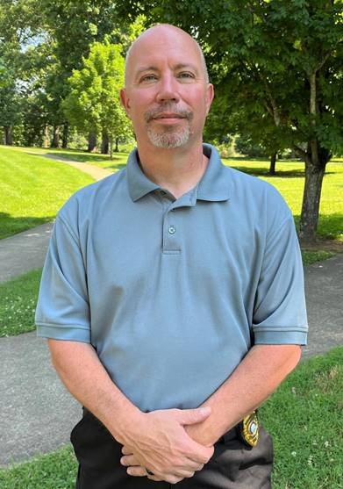

Shane Matthews

**Support food drive for summer residential students**

Some of our students have needed to stay in the residence halls this summer, and we can support them.

The Bonner Leader Program is holding a food drive for these students through the summer. To support this initiative, you can leave perishable food items in the bin by the Old Gym in the Scott M. Niswonger Commons or at the Center for Civic Advancement, which is located in Room 401 of that building.

The Bonner Leaders’ goal is to distribute food every Thursday.

You are also welcome to make a monetary donation [here](https://ssl.charityweb.net/tusculum/). Select the student emergency fund or the food pantry in the drop-down menu.

**Spring honors lists released**

The Registrar’s Office has released the spring semester honors list. It is once again an impressive document, which includes members of the President’s as well as Dean’s and Charles Oliver Gray lists.

We congratulate all of the students who have demonstrated academic excellence! They are career-ready professionals who have demonstrated the value of a Tusculum education.

You can view the list [here](https://www3.tusculum.edu/news/tusc-family/2022/spring-semester-2022-honors-list/).

**Free tickets available for Greeneville Flyboys games**

Faculty and staff members are eligible to receive free tickets for Greeneville Flyboys home games at Pioneer Park this year.

Anyone who is interested should submit a request to [tuwork@tusculum.edu](mailto:tuwork@tusculum.edu) no later than noon on a game day or by noon on Friday for weekend games. Employees are eligible to reserve as many as four tickets while supplies last. If the university has not issued its total allotment of tickets as of the noon deadline, an employee can obtain additional ones.

The Facilities Management Department processes requests on a first-come, first-served basis.

The home opener is tonight at 7. To see the season schedule, please click [here](https://www.appyleague.com/greeneville/schedule/2022-06).



**Spread the word about our summer camps for children of all ages**

We remind you Tusculum will host several affordable summer camps in June and July. They are:

* Tool School, July 11-15
* Find Your Food, Find Your Fun, June 20-24 or July 25-29
* Health Professions Day Camp, July 19
* Theatre Camp at Tusculum, July 25-29

We encourage your families to participate and ask that you alert others as well.

An additional Tool School camp, scheduled for this week, was canceled.

You can read more about the camps in this [news release](https://www3.tusculum.edu/news/news/2022/multiple-summer-camps-at-tusculum-to-provide-active-and-experiential-learning-opportunities-for-children-of-all-ages/). Additional details and registration are available at <https://tusculumuniversitycamps.totalcamps.com/>. For more information, please email Greg Fay, director of continuing education and camps, at [gfay@tusculum.edu](mailto:gfay@tusculum.edu).



**High school students in Upward Bound busy in the summer program on campus**

Last week, we welcomed high school students who are participating in the Upward Bound and Upward Bound Math and Science program on campus for five weeks.

You have probably seen the students walking around campus. We are proud to host these students every year and are grateful to Tusculum family members who are teaching classes and serving as residential advisors.

After their five weeks of studies and various other activities, the high school students can take part in a weeklong trip to New Orleans chaperoned by TRIO personnel.

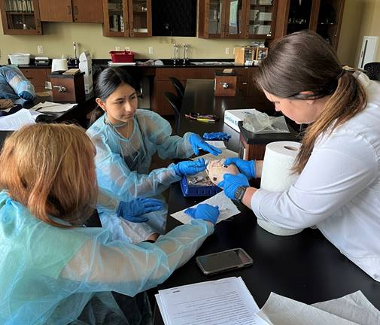

Participants in the summer program dissected a pig’s heart last week. Photo by the Office of Communications and Marketing. Additional photos of the high school students and the summer staff are available [here](https://www3.tusculum.edu/news/tusc-family/2022/upward-bound-and-upward-bound-math-and-science-photos/).

**Funding renewed for Tusculum’s Upward Bound grants**

We are pleased to share that the U.S. Department of Education has extended funding for another five years for the university’s two Upward Bound programs. Tusculum’s longest-serving Upward Bound program has been in existence since 1973 and serves students from Greene, Unicoi and Washington counties. The university’s other Upward Bound program serves students in Cocke and Hawkins counties and was first funded in 2002.

This continues a successful cycle in which Tusculum earned renewals for Student Support Services and ARCHES in 2020 and the two Talent Search grants in 2021. TRIO has also applied to continue the Upward Bound Math and Science grant, and word on that is not expected until at least August.

Tusculum’s TRIO programs are designed to identify and provide services for individuals from disadvantaged backgrounds. They help low-income individuals, first-generation college students and people with disabilities progress from middle school to successful completion of their postsecondary education.

Rachael Barnett leads the Student Support Services and ARCHES programs, which serve Tusculum students. Dr. David Smith oversees the university’s pre-college outreach TRIO Programs, which cater to students from middle school through high school.

We congratulate all TRIO team members for their diligence in making a positive difference in students’ lives! As a result of their commitment, these students are better prepared to be career-ready professionals!

**Bargain prices and knocking out credits are a winning formula for the summer!**

Students can still register for the late term, which runs from June 27-Aug. 12. The financial benefit is huge!

Students can save $418 per credit hour – 53 percent – for undergraduate courses compared to the fall and spring semesters by taking summer courses! The cost for these courses is just $365 per credit hour.

Federal financial aid is available to students to cover their tuition costs, too!

The link to the portal is <https://portal.tusculum.edu/CMCportal/>. The students’ login is their Tusculum lab account. This is the same username and password utilized for Canvas.

Students should check with the Tusculum financial aid team and their advisor. Students cannot register for the summer terms if they have a business hold or have not met with their advisor.



**Do not forget to take care of registration for fall courses**

Students who have not completed their registration for fall classes should complete that task as quickly as possible. They can review courses available during the fall semester by visiting the portal.

It is important for students to remember:

* They must meet with their advisor before they can choose their courses.
* They must not have a business office hold on their student account because they will not be able to register for courses until they resolve it.



**Remember to register for housing**

As students review and register for courses, they should also take a few moments to sign up for housing.

The application is available at <https://my.tusculum.edu/forms/housing-lottery-form/>.

Here are a few important reminders about housing registration:

* Students will not be able to participate in the housing lottery if they have not registered for courses to be held in the fall.
* Students need to complete a housing application on their Anthology accounts.
* Students who have a business office hold can submit their housing application, but it will not be processed until they register for classes for the fall.



**Revised hours for the library in June and July**

Due to our schedule conversion for June and July, the Thomas J. Garland Library has adjusted its hours to 8 a.m.-6 p.m. Monday-Thursday. Virtual assistance is available Fridays via chat or email.

Please see the graphic below for more details.



**Check out the new look outside Virginia Hall!**

If you have walked by Virginia Hall in the last couple of weeks, you have noticed some differences in the appearance.

On days when the Office of Admission is conducting tours, the group plants welcome banners that lead potential new Pioneers to the front entrance of Virginia. Dr. Jacob Fait, vice president of enrollment management and financial aid, also installed two swings, featuring orange seats, near the front of the building.

In addition, the office has purchased a large Connect Four game and cornhole boards and bags for use on the patio. Many tree limbs that had started to obscure the view of the building were removed as well. Plus, the Office of Admission created an even more comfortable environment indoors by removing excess furniture and adding plants. Coming soon will be music playing from the building and a photo station at the building for prospective students.

“We want to create the most inviting and fun atmosphere possible as future Pioneers begin and end their tour on campus,” Dr. Fait said. “In addition to receiving an active and experiential education at our university that equips them to be career-ready professionals, our students have multiple opportunities to have fun at Tusculum. We want students who are considering enrolling at Tusculum to know that from the moment they step on our campus for the first time.”

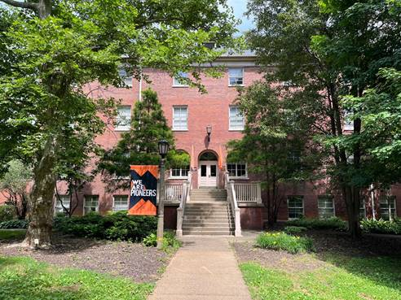



These photos show the updated look of Virginia Hall and the new games outside the building. Photos by the Office of Communications and Marketing

**GEM Award goes to beloved assistant athletic director**

Dom Donnelly, assistant athletic director for communications, is the newest recipient of the President’s GEM Award. Dr. Hummel announced him as the May recipient during the President’s Coffee Thursday, May 26.

A Tusculum family member for more than 20 years, Donnelly is beloved and respected throughout the university and is an encyclopedia about all aspects of the Pioneers. Here are some of the comments his colleagues at Tusculum shared about him.

* “You can always count on Dom to do his absolute best, to be a professional, and often times going above and beyond the call of duty. Dom has gone the extra mile many times in an effort to be there for our students, many of which call him friend. There is no one better than Dom Donnelly and Tusculum is extremely fortunate to have him.”
* “Dom, is a relentless worker. No one actually understands the amount of hours he puts towards our students’ success. He is always taking a backseat so others can shine. He never seeks credit or recognition for his work. He only wants to ensure that Tusculum and its mission is being displayed for others to see. He’s willing to lend an extra hand wherever and whenever it’s needed.”
* “Dom has been a staple for this institution since the day he started working here. He puts his all into everything that he does and will do anything for all of the student-athletes on campus. He cares for everyone around him and will spend late hours here so he can ensure that the news stories of our athletic contests are out for the next morning.”
* “He also has a kind heart, demonstrating the value of lifting up others and having a positive outlook. He is an excellent example of an employee who puts our caring Christian environment into action with the way he treats others. He also provides students with abundant opportunities at home games to achieve an active and experiential education that helps prepare them to be career-ready professionals.”

In addition to the GEM Award, Donnelly received the 2022 David Riggins Service Award last week at the South Atlantic Conference annual meeting! This award goes to an administrator for outstanding service to that person’s institution and the conference.



Dom Donnelly

**Sidewalk work continues near the tennis courts**

The Facilities Management Department has progressed with safety measures near the Nichols Tennis Center.

Crews have dug the area and begun installing the forms where the new sidewalk will be built from the top of the steps to the asphalt outdoor basketball court. Chad Grindstaff, facilities management director, said he hopes to be able to pour concrete for the sidewalks by the middle of the week. That hinges on the weather.

Earlier, the facilities team built sidewalks on the Scott M. Niswonger Commons side of Shiloh Road. Additional safety features to come are fencing on the tennis courts side of Shiloh and a signal by the crosswalk by the entrance to the Indoor Practice Facility parking lot.

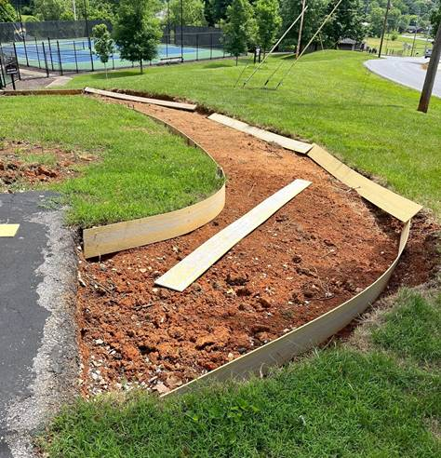

Preparatory work is underway for the newest section of sidewalks to increase safety in that part of campus. Photo by the Office of Communications and Marketing

**Two-factor authentication is coming soon to Tusculum**

This is a friendly reminder to faculty and staff members that Duo two-factor authentication enrollment time has arrived.

You should have received an email from the Duo enrollment system Thursday, May 19. This email contains a personalized link allowing you to enroll with Duo. This two-minute self-enrollment process enables you to register your phone and install the Duo Mobile application. If you do not have a smartphone, you can enroll a regular cell phone (SMS and calls) or landline (calls) for two-factor authentication. All faculty/staff users must enroll in advance of the go-live date, which will be announced soon.

We are still working to prepare and test our systems for this additional layer of security but we could be announcing the go-live date as early as this week, so please enroll soon. If you did not receive your personalized enrollment email on May 19, please email [tdis@tusculum.edu](mailto:tdis@tusculum.edu) so it can be re-sent.

You can install the Duo app on your phone any time before or during the enrollment process. Remember, when the Duo app pushes an authentication request to your phone, it only uses 1 MB of data per 500 pushes.

iPhone:  <https://apps.apple.com/us/app/duo-mobile/id422663827>

Android: <https://play.google.com/store/apps/details?id=com.duosecurity.duomobile&hl=en>

**To learn about the Duo enrollment process and about Duo, please refer to the email sent Friday, June 3, from the Office of University Communications.**

**Reminder**

* If you are holding an event on campus, we need to be sure Tusculum family members are aware. One way is to submit a [branding request](https://iasite.tusculum.edu/branding-project-request-form/) to the Office of Communications and Marketing, which will post the event to the calendar on the Tusculum website. Another is for employees to work with the person designated in their office or department who has the ability to post items on the Events and Planning Calendar on Outlook. Access to items on that calendar is available to all employees.

**Events and activities**

**All Tusculum family members**

Tuesday, June 7; Thursday, June 9; Tuesday, June 14; and Thursday, June 16, 7 p.m., Chalmers Conference Center; **REFIT fitness class**

Thursday, June 9, 6 p.m., Meen Center lecture hall; **“Sketches of East Tennessee History” lecture “Who Was John Gloucester?: Race, Place, and Religion at Greeneville College in 1806”**

**Faculty and staff**

Wednesday, June 15; Thursday, June 16; and Friday, June 17, all day, Meen Center lecture hall; **Talent Search Robotics Camp**

Thursday, June 16; Friday, June 17; and Saturday, June 18, all day, Annie Hogan Byrd Fine Arts Center; **Tusculum Music Camp**

Thursday, June 16, 9 a.m., Zoom; **Operation Success Committee**

Friday, June 17, 9 a.m., Greeneville campus; **Pioneer Quest**

**Community**

Saturday, June 11, and Saturday, June 18, 9 a.m., Doak House Museum; **Greeneville Farmers Market**

Monday, June 13, all day, Thomas J. Garland Rooms 105, 108 and 110; **Farm Bureau meeting**

**Faculty and staff birthdays**

* Tuesday, June 7 – Dr. Stella Schramm
* Thursday, June 9 – Makyla Wyatt
* Sunday, June 12 – Audrey Brackens
* Monday, June 13 – Amy Franklin
* Thursday, June 16 – Amanda Kyker
* Saturday, June 18 – Justin Chartrand

We thank you for reading The Pioneer Press! To suggest content for a future edition or submit feature photos, please email Jim Wozniak, director of communications and marketing, at [jwozniak@tusculum.edu](mailto:jwozniak@tusculum.edu).

**Go Pioneers!**