

Dear Tusculum family,

**In this edition:**

·         [President’s Perspective](applewebdata://0415273D-03CE-4F9B-8862-A52F2F6E15D4#Book)

·         [Word of the Week](applewebdata://0415273D-03CE-4F9B-8862-A52F2F6E15D4#Book2)

·         [Photo of the Week](applewebdata://0415273D-03CE-4F9B-8862-A52F2F6E15D4#Book3)

·         [Coronavirus update](applewebdata://0415273D-03CE-4F9B-8862-A52F2F6E15D4#Book4)

·         [Health clinic closing after this week for the summer](applewebdata://0415273D-03CE-4F9B-8862-A52F2F6E15D4#HealthClinic)

·         [Dr. Hummel speaking at chapel today](applewebdata://0415273D-03CE-4F9B-8862-A52F2F6E15D4#LastChapel)

·         [Honors Convocation Thursday](applewebdata://0415273D-03CE-4F9B-8862-A52F2F6E15D4#HonorsConvocation)

·         [Choose summer classes](applewebdata://0415273D-03CE-4F9B-8862-A52F2F6E15D4#SummerClasses)

·         [Register for fall classes](applewebdata://0415273D-03CE-4F9B-8862-A52F2F6E15D4#FallRegistration)

·         [Sign up for housing](applewebdata://0415273D-03CE-4F9B-8862-A52F2F6E15D4#RegisterHousing)

·         [Grand opening for The Pioneer Perk](applewebdata://0415273D-03CE-4F9B-8862-A52F2F6E15D4#PioneerPerk)

·         [Midnight Breakfast](applewebdata://0415273D-03CE-4F9B-8862-A52F2F6E15D4#LateNighBreakfast)

·         [“Schoolhouse Rock Live! Jr.” performances](applewebdata://0415273D-03CE-4F9B-8862-A52F2F6E15D4#SchoolhouseRock)

·         [The Comfy Chef this week’s food truck](applewebdata://0415273D-03CE-4F9B-8862-A52F2F6E15D4#FoodTruck)

·         [Old Oak Festival](applewebdata://0415273D-03CE-4F9B-8862-A52F2F6E15D4#OldOak)

·         [Caleb Johnson concert](applewebdata://0415273D-03CE-4F9B-8862-A52F2F6E15D4#CalebJohnson)

·         [Academic Symposium](applewebdata://0415273D-03CE-4F9B-8862-A52F2F6E15D4#AcademicSymposium)

·         [College of Civic and Liberal Arts honors ceremony](applewebdata://0415273D-03CE-4F9B-8862-A52F2F6E15D4#HonorsCeremony)

·         [GEM nominations](applewebdata://0415273D-03CE-4F9B-8862-A52F2F6E15D4#GEM)

·         [President’s Coffee](applewebdata://0415273D-03CE-4F9B-8862-A52F2F6E15D4#PresidentCoffee)

·         [Shuttles for students](applewebdata://0415273D-03CE-4F9B-8862-A52F2F6E15D4#Shuttles)

·         [President’s Society applications](applewebdata://0415273D-03CE-4F9B-8862-A52F2F6E15D4#PresidentSocietyApp)

·         [Reminders](applewebdata://0415273D-03CE-4F9B-8862-A52F2F6E15D4#Reminders)

·         [Events and activities](applewebdata://0415273D-03CE-4F9B-8862-A52F2F6E15D4#Activities)

·         [Faculty and staff birthdays](applewebdata://0415273D-03CE-4F9B-8862-A52F2F6E15D4#Birthdays)

**President’s Perspective**

Talent was on full display last week.

The College of Civic and Liberal Arts held its honors ceremony, which demonstrated the incredible talent and hard work of our students and faculty. Their achievements make me proud to be a Pioneer. The student talent show Friday night was a lot of fun and revealed impressive skills.

Greene County is blessed with so much talent. I saw talent from one end of the Old Oak Festival to the other. Several of our students read their poetry and other writings. Our own Richard Miller, associate vice president of institutional effectiveness and research, is a talented craftsman who sold his pens at the festival. At the Caleb Johnson concert, I was blown away by Michael Hawkins, associate head athletic trainer, as he played the drums.

This next week we will see more talent highlighted at the College of Education’s honors event at 6 p.m. Wednesday, April 27; the university-wide Honors Convocation at 10:30 a.m. Thursday, April 28, and the Academic Symposium Friday morning, April 29.

Tusculum is blessed by so many talented students, faculty and staff. Don’t neglect your talents; use them for God’s glory and the enrichment of those around you.

Go Pioneers!

Dr. Scott Hummel  
President

**Word of the Week**

“His master said to him, 'Well done, good and faithful servant. You have been faithful over a little; I will set you over much. Enter into the joy of your master.'” – Matthew 25:23 (ESV)

**Photo of the Week**

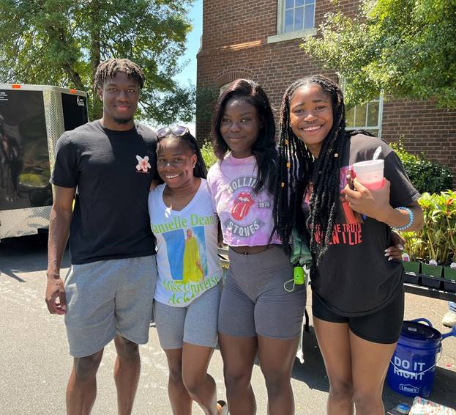

Left to right, students Jarvis Barber Jr., Aliyah Adderley, Destiny Lottie and Sylvia Bah enjoy the Old Oak Festival Sunday. Photo by the Office of Communications and Marketing

**Coronavirus update**

No students and no employees are positive.

Should you develop coronavirus symptoms, be diagnosed or be identified as a contact, you must immediately inform the appropriate group at Tusculum.

·         Students need to email the Office of Student Affairs at [studentaffairs@tusculum.edu](mailto:studentaffairs@tusculum.edu) or call the COVID-19 hotline at 423-636-0500. They should also alert their professors.

·         Employees must contact the Human Resources Department at [humanresources@tusculum.edu](mailto:humanresources@tusculum.edu) or 423-636-7345 (extension 5345 on campus) as well as their supervisor.

**Health clinic to close for the summer after this week, will resume care in the fall**

This will be the last week for the Ballad Health Tusculum University Clinic to be open until the fall semester.

The clinic, located in Room 008 on the ground floor of the Meen Center will be open Wednesday 8-11:30 a.m. and Thursday from 1-3:30 p.m. this week.

No appointment is necessary. Patients can self-pay or use their health insurance. Students can apply for payment aid, if necessary.

We appreciate all of the students, faculty and staff who have entrusted their care to the clinic this academic year. We look forward to reopening for the fall semester.

**Today is the last chapel of the academic year; Dr. Hummel is the speaker**

Chapel will be held today from 3:30-4 p.m. in the chapel in Annie Hogan Byrd Fine Arts Center and via Zoom at <https://tusculum.zoom.us/j/86025009185?pwd=dG9yMUdQL1MyZWJLRXROUllrZ2tZZz09>.

This will be the final chapel for this academic year. We will not have a session next Monday because of Finals Week. Chapel will resume at the start of the fall semester in August.

**Honors Convocation to recognize excellence at Tusculum is Thursday**

Honors Convocation is 10:30 a.m. Thursday, April 28, in the Marilyn duBrisk Theatre of Annie Hogan Byrd Fine Arts Center. Everyone is invited and encouraged to attend.

Please see the graphic below for the revised class times. In addition, the cafeteria will be closed from 10:30-11:30 a.m. Offices are welcome to put a note on their doors indicating they are closed during that hour to attend the convocation.

Come to the Honors Convocation to see if you have won an award – and support your fellow Tusculum family members.

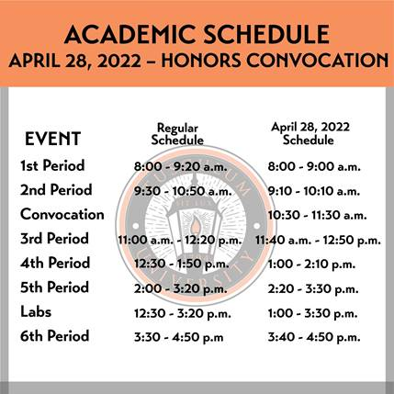

**Summer classes are half off!**

Students can save $418 per credit hour – a 53 percent savings – for undergraduate courses compared to the fall and spring semesters by taking summer courses! For just $365 per credit hour, students can put themselves closer to earning their degree and ease their load in the spring and fall semesters. Students can utilize federal financial aid to cover their tuition costs, too!

Registration is already underway for the three summer terms.

·         Full – May 16-Aug. 12

·         Early – May 16-June 24

·         Late – June 27-Aug. 12

The link to the portal is <https://portal.tusculum.edu/CMCportal/>. The students’ login is their Tusculum lab account. This is the same username and password that is used for Canvas.

Students should check with the Tusculum financial aid team and their advisor, who can guide them through the process. Students cannot register for the summer terms if they have a business hold or have not met with their advisor.



**Take care of registration for fall courses**

Students can review the courses available during the fall semester by visiting the portal. They should register as soon as possible before classes fill up.

It is important for students to remember:

·         They must meet with their advisor before they can choose their courses.

·         They must not have a business office hold on their student account because they will not be able to register for courses until they resolve it.



**Remember to register for housing**

Students who have not yet registered for housing should take care of that matter as quickly as possible.

The application is available at <https://my.tusculum.edu/forms/housing-lottery-form/>.

A few quick points about housing registration:

·         Students will not be able to participate in the housing lottery if they have not registered for courses to be held in the fall.

·         Students need to complete a housing application on their Anthology accounts.

·         Students who have a business office hold can submit their housing application, but it will not be processed until they register for classes for the fall.



**Grand opening for The Pioneer Perk is Tuesday**

Tusculum will hold a grand opening for The Pioneer Park, a new place on campus for students to relax and have fun, Tuesday, April 26, at 3:30 p.m.

The Pioneer Perk, located in the bookstore, will provide room for students to enjoy coffee and play a variety of games, such as billiards, table tennis and air hockey.

We will have a ribbon cutting and reveal the murals, which were designed by students, Lilliana Gall and Gweneth Gustafson. We also received assistance on the mural from Jason Emmette, owner of Silver Star Design Co.

Once the ceremony concludes, we will have coffee tastings. Later in the day, we will have table tennis and billiards tournaments. We will have karaoke and open microphone Wednesday evening, April 27.

Tusculum welcomes donations to support this project. You can make your donation [here](https://ssl.charityweb.net/tusculum/). When you are asked “Please use my donation for,” choose “The Pioneer Perk.” When you are asked toward the bottom of the page the reason for your gift, please choose “#PioneersGive.”



**Yummy late-night breakfast available for students**

Good news! The breakfast is back for the spring semester! **We will hold it Sunday, May 1, starting at 10 p.m. The event will conclude at midnight.**

Students should come ready for a delicious spread of pancakes, eggs, sausage and bacon prepared and served by Dr. Hummel as well as faculty and staff members.

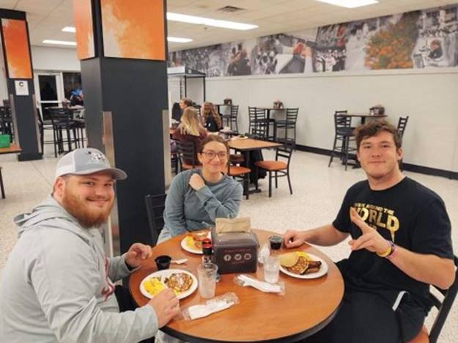

Left to right, students Jackson Krauss, Cristine Moore and Jackson Fritts participate in the Midnight Breakfast in December.

**Three performances of “Schoolhouse Rock Live! Jr.” remain**

Early reviews of “Schoolhouse Rock Live! Jr.” are positive, and we encourage you to see this impressive show.

The cast has also already performed three shows the Behan Arena Theatre on the lower level of Annie Hogan Byrd Fine Arts Center. Remaining dates and times are April 29 and April 30 at 7 p.m. and May 1 at 2 p.m.

Students and employees are eligible to receive one free ticket. Other tickets are $17 for anyone 12-59, $15 for audience members 60 and older and $5 for children younger than 12. You can obtain a seat by calling Arts Outreach at 423-798-1620 or emailing Jennifer Hollowell, director of Tusculum’s Center for the Arts, at[jhollowell@tusculum.edu](mailto:jhollowell@tusculum.edu).

To learn more, please read this [news release](https://www3.tusculum.edu/news/news/2022/schoolhouse-rock-live-jr-featuring-those-iconic-songs-coming-to-tusculum-university-for-six-energetic-shows/).



Cast members rehearse a scene in “Schoolhouse Rock Live! Jr.” Photo by the Office of Communications and Marketing

**The Comfy Chef is this week’s food truck**

The Comfy Chef will be the food truck on campus Wednesday.

Come ready to feast Wednesday, April 27, from 11 a.m.-3 p.m. in front of the Scott M. Niswonger Commons.

See you in front of Niswonger! We have enjoyed the fellowship as students, faculty and staff come for great meals prepared by our food truck vendors.



**The Old Oak Festival was a tremendous success!**

More than 2,000 guests joined us for the Old Oak Festival during the weekend, and everyone enjoyed the experience. We are grateful to everyone who contributed to the event’s success!

The weekend started off exceptionally with the talent show for our students, and we appreciate all of them who participated. Landry Tea won the talent show, with Ashley Howell finishing second and Cole Robertsen coming in third. Their singing was spectacular!

We were also pleased to see so many of our students assist as volunteers and take time to participate in other ways during the festival. We are already planning the 2023 Old Oak Festival and look forward to having that one be a resounding success as well.

Please visit [this gallery](https://www3.tusculum.edu/news/tusc-family/2022/2022-old-oak-festival-photos/) of photos from the festival that were taken by the Office of Communications and Marketing. You can also visit Tusculum’s [Facebook](https://www.facebook.com/tusculum.univ) and [Instagram](https://www.instagram.com/tusculum.univ/) pages to see the photos.

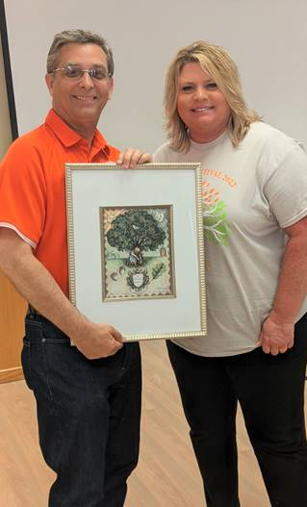

Dr. Hummel holds the Old Oak Festival watercolor developed by Bill Bledsoe, assistant professor of art and design. He is standing with Nicole Rader, director of alumni and community engagement. Photo from the Office of Institutional Advancement

**Caleb Johnson performed an outstanding show on campus**

Caleb Johnson demonstrated why he is one of the bright young stars in rock-n-roll with his performance Saturday, April 23, in the Marilyn duBrisk Theatre.

His high-energy show contained an excellent mix of rock songs and interaction with the audience. We can easily see why he was picked the season 13 winner of “American Idol”!

In addition to the photo below, you can view [this gallery](https://www3.tusculum.edu/news/tusc-family/2022/caleb-johnson-concert-4-23-22/) taken by the Office of Communications and Marketing.



Caleb Johnson, second from the right, performs during his concert. Photo by the Office of Communications and Marketing

**Hear from our students at the Academic Symposium Friday**

Our students will showcase their research skills during the Academic Symposium from 9:30 a.m.-12:30 p.m. Friday, April 29, in the Scott M. Niswonger Commons.

The event will begin in Chalmers Conference Center with comments from Dr. Hummel. That will be followed by poster presentations and art and history exhibits in Chalmers.

Students will present their research in Niswonger Rooms 403 and 313. The event will conclude with an ice cream social in Chalmers from 11:30 a.m.-12:30 p.m.

We encourage all Tusculum family members to support our students and reinforce the value of research as part of a Tusculum education.

**College of Civic and Liberal Arts holds honors ceremony**

A jovial mood permeated the Clem Allison Gallery of the Shulman Center Thursday, April 21, as the College of Civic and Liberal Arts held its honors ceremony.

Savanna Draper, who graduated from Tusculum in 2018 with a major in political science and a minor in history, was the keynote speaker, and she delivered inspiring remarks to the college’s students, faculty and staff.

Dean Wayne Thomas highlighted many of the special moments from the academic year, such as Celebrating Diversity Week, Ledford scholar activity and grants from the Council of Independent Colleges, restarting the Tusculum Band, the continuation of plays, the dedication of the Marilyn duBrisk Theatre and service breakfasts at the Doak House Museum.

Thomas also noted that the coronavirus continued to bring challenges, and he praised the seniors in the college for working their way through them.

“Whether you’re at the top of your class or near the bottom, I admire your fortitude, your perseverance, your ability to self-motivate,” he said. “You’ve faced down the unknown for two years, you adapted and you made it.”

To see the list of award winners, please click [here](https://www3.tusculum.edu/news/tusc-family/2022/ccla-award-winners-for-2021-22/). Additional photos taken by the Office of Communications and Marketing are available in [this gallery](https://www3.tusculum.edu/news/tusc-family/2022/photos-from-the-ccla-ceremony-4-21-22/).

The College of Education will hold its honors event from 6-7 p.m. Wednesday, April 27, via Zoom to honor undergraduate adult and online studies students and graduate student convocation awardees. The link is<https://tusculum.zoom.us/j/82473025683>.

The College of Nursing will hold its pinning ceremony at 5:30 p.m. Friday, May 6 in Pioneer Park but will move to Pioneer Arena in case of inclement weather.

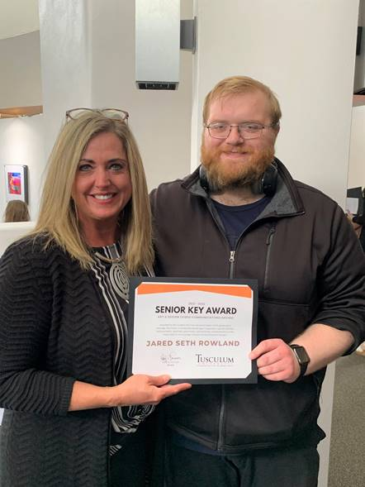

Lanna Monday, assistant professor of art and design, presented the Senior Key Award for art and design (visual communication design) to Jared Rowland. Photo from Kaitlin Irvin

**GEM nominations due Wednesday**

The deadline for faculty and staff members to recommend a college for the President’s GEM Award is noon Wednesday, April 27. Dr. Hummel will announce the winner at the President’s Coffee Friday, April 29.

To suggest someone, please complete this [short form](https://my.tusculum.edu/forms/presidents-gem-award-nomination-form/).

GEM is an acronym for Going the Extra Mile. Attributes to consider in a nominee are integrity, a positive attitude, a spirit of excellence and a dedication to Tusculum and its students. A faculty or staff member who goes beyond the call of duty, makes the Tusculum family stronger and contributes to the university’s caring Christian environment is an ideal candidate. The nominee should exemplify the university’s mission, vision and values.

The April recipient will succeed Bobbie Clarkston, athletic academic advisor, who was selected for the GEM Award in March.

**President’s Coffee being held at an earlier time**

To accommodate the Academic Symposium, this month’s President’s Coffee will take place at 8:45 a.m. Friday, April 29. This is 15 minutes earlier than the normal starting time for the coffee.

The coffee will be held in Chalmers Conference Center and via Zoom at<https://tusculum.zoom.us/j/89419836133?pwd=RGplWkxyeDZBNkJuZ2dXK21qRnEwZz09>. We encourage everyone to attend in person, if possible, but we understand others might need a remote option for this meeting.

During the meeting, Dr. Hummel will provide his monthly update, and Dr. Jacob Fait, vice president of enrollment management and financial aid, is scheduled to make some remarks.

**Tusculum offers shuttles for students who are flying**

Students who plan to fly home at the end of the spring semester are eligible to receive shuttle service from the Greeneville campus. Tusculum provides shuttle service to Tri-Cities Airport, McGee Tyson Airport in Knoxville and the Asheville, North Carolina, airport.

Student-athletes need to sign up with their coaches. All other students can sign up in the Office of Student Affairs. These shuttles will be available from Monday, May 2, through Monday, May 9.

For the fall semester, shuttle signups will begin Monday, July 25. Shuttles will be available from Monday, August 8, until Tuesday, August 18. Shuttles will run from 10 a.m.-7 p.m. We encourage students to book flights that meet these periods, as shuttles may not be available outside these windows. Students who arrive after the 7 p.m. shuttle should plan for overnight lodging and utilize the next morning’s shuttle.

Nonathletes will need to email the Office of Student Affairs at [studentaffairs@tusculum.edu](mailto:studentaffairs@tusculum.edu) to schedule and confirm a shuttle time.

Students will be charged $25 if they use the shuttle service. The cost will be added to their student account. They do not need to pay the shuttle driver.

**Submit your application for President’s Society**

Students interested in serving in the President’s Society for the 2022-23 academic year can submit their applications to the Office of Admission.

The President’s Society works closely with the Office of Admission and the President’s Office to recruit students. Members of the President’s Society give tours to potential students and their families on a Saturday rotation and assist in other campus visit days, open houses, new student registration and other important events on campus. Additionally, members work one day a week on call in the Office of Admission.

Applicants must be undergraduates who have at least reached the second semester of their freshman year. Other requirements include a grade point average of at least 3.0 and a letter of recommendation from a faculty or staff member.

The application is attached and is also available from Raegan Goodson, admissions representative and campus visit coordinator, on the first floor of Virginia Hall. Completed applications can be brought to Goodson or emailed to [rgoodson@tusculum.edu](mailto:rgoodson@tusculum.edu).

The deadline for applications is Monday, April 25. Interviews will take place Tuesday, April 26.

**Reminders**

·         All Tusculum family members are invited to attend the free opening receptions for art and design students’ capstone exhibitions. They are held from 5-7 p.m., and the students available to answer any questions by guests. Here are the remaining reception dates and students:

o   Thursday, April 28 – Carli Pigza

o   Thursday, May 5 – Daniel Gongora and Emilie Hansen

·         If you are holding an event on campus, we need to be sure Tusculum family members are aware. One way is to submit a [branding request](https://iasite.tusculum.edu/branding-project-request-form/) to the Office of Communications and Marketing, which will post the event to the calendar on the Tusculum website. Another is for employees to work with the person designated in their office or department who has the ability to post items on the Events and Planning Calendar on Outlook. Access to items on that calendar is available to all employees.

**Events and activities**

**All Tusculum family members**

Monday, April 25, 3:30 p.m., Annie Hogan Byrd Fine Arts Center and Zoom (<https://tusculum.zoom.us/j/86025009185?pwd=dG9yMUdQL1MyZWJLRXROUllrZ2tZZz09>); **chapel**

Monday, April 25, and Tuesday, April 26, 5:30 p.m., Chalmers Conference Center; **yoga**

Monday, April 25, 7:30 p.m., Marilyn duBrisk Theatre; **Tusculum University Community Choir concert**

Tuesday, April 26, 3:30 p.m., bookstore;**grand opening for The Pioneer Perk**

Tuesday, April 26, 7 p.m., Pioneer Arena; **REFIT fitness class**

Wednesday, April 27, 11 a.m., in front of Scott M. Niswonger Commons; **food truck (The Comfy Chef)**

Wednesday, April 27, 4 p.m., Chalmers Conference Center; **Lantern Festival (invite only)**

Wednesday, April 27, 6 p.m., Zoom (<https://tusculum.zoom.us/j/82473025683>); **College of Education honors ceremony**

Thursday, April 28, 10:30 a.m., Marilyn duBrisk Theatre;**Honors Convocation**

Thursday, April 28, 5 p.m., Shulman Center; capstone exhibition opening reception for Carli Pigza

Thursday, April 28, 7 p.m., Marilyn duBrisk Theatre;**Tusculum Band spring concert**

Thursday, April 28, 7 p.m., Pioneer Arena; **REFIT fitness class**

Friday, April 29, 8:45 a.m., Chalmers Conference Center and Zoom (<https://tusculum.zoom.us/j/89419836133?pwd=RGplWkxyeDZBNkJuZ2dXK21qRnEwZz09>); **President’s Coffee**

Friday, April 29, 9:30 a.m., Chalmers Conference Center and Niswonger 313 and 403; **Academic Symposium**

Friday, April 29, and Saturday, April 30, 7 p.m., Behan Arena Theatre; **“Schoolhouse Rock Live! Jr.”**

Saturday, April 30, 7 p.m., Pioneer Arena; **REFIT fitness class**

Sunday, May 1, 2 p.m., Behan Arena Theatre; **“Schoolhouse Rock Live! Jr.”**

**Faculty and staff**

Monday, April 25, 6 p.m., Meen Center lecture hall;**Upward Bound event**

Wednesday, April 27, noon, Zoom; **The Pioneer Pathway Task Force**

**Students**

Thursday, April 28, 5:30 p.m., Chalmers Conference Center; **Student Support Services spring banquet**

**Community**

Monday, April 25, 5:30 p.m., Annie Hogan Byrd Fine Arts Center; **Great Literature Alive, Well, & Playing in Greeneville, Tennessee, class**

Tuesday, April 26, 7 p.m., chapel in Annie Hogan Byrd Fine Arts Center; **Greene County Community Band rehearsal**

**Athletics**

Friday, April 29, 4 p.m., Lincoln Memorial University; **softball team vs. Lenoir-Rhyne in the South Atlantic Conference tournament**



Anna Alloway hit her 30th career home run for the Pioneer women’s softball team Thursday against the University of Virginia’s College at Wise. With that homer, she became the all-time leader. You can see the historic shot [here](https://www.facebook.com/TusculumSports/videos/412233530289534). Photo from the Office of Athletic Communications

***Athletic contests can change. Be sure to check the schedule on the***[***athletics*website**](https://www.tusculumpioneers.com/landing/index)**for*revisions.***

**Faculty and staff birthdays**

·         Tuesday, April 26 – Matt Bible

·         Tuesday, April 26 – Melissa White

·         Wednesday, April 27 – Malik Slater

·         Wednesday, April 27 – Dr. Thomas Talley

·         Thursday, April 28 – Debra Foster

·         Friday, April 29 – Dionte Ferguson

·         Saturday, April 30 – Shawn Bergquist

·         Sunday, May 1 – Dr. Kurtis Miller

·         Sunday, May 1 – Lelia Dykes

We appreciate you for reading The Pioneer Press! To suggest content for a future edition or submit feature photos, please email Jim Wozniak, director of communications and marketing, at [jwozniak@tusculum.edu](mailto:jwozniak@tusculum.edu).

**Go Pioneers!**