

June 20, 2022

We hope all of the men who have been blessed with children enjoyed a terrific Father’s Day! We also celebrate Juneteenth and reflect on the importance of that special day.

**In this edition:**

·         President’s Perspective

·         Word of the Week

·         Photo of the Week

·         Tusculum’s new campus minister

·         Appalachian Environment Studies summer lecture series starting Tuesday

·         History Summer Lecture Series sessions continue Wednesday

·         Tusculum garage sale Thursday and Friday

·         Dr. Hummel appears on local public affairs program

·         Ledford scholars needing participants for their research projects

·         Supporting food drive for summer residential students

·         Summer camps for children of all ages coming in July

·         Tusculum Family Reunion slated for Aug. 15

·         Band Camp held on campus

·         Large turnout for basketball camp at Tusculum

·         Former Pioneer wins golf tournament

·         Alumnus, current student featured in local business magazine

·         Last chance to register for summer classes

·         Registering for fall courses

·         Signup for housing

·         Updated financial forms

·         Reminders

·         Events and activities

·         Faculty and staff birthdays

**President’s Perspective**

Today, friends of Tusculum University and I were at the Sea of Galilee. I have been here many times, but every time I learn new lessons.

While crossing on a boat, we stopped in the middle of the Sea and turned off the engine. Everything immediately became quiet. The stillness reminded me of Jesus calming the storm and the encouragement of Psalm 46 to “be still and know that I am God.” The COVID-19 storm might be fading, but other storms are coming, whether they are health, financial or relational. We often experience God’s presence most intensely in the midst of the storm.

As we came ashore, we made our way to Capernaum, where Peter lived and Jesus healed those brought to him. Not far around from Capernaum, we walked and paused on the Mount of Beatitudes, where Jesus gave his Sermon on the Mount. We are still challenged to live by his teachings to “go the extra mile,” “love our enemies” and to be “salt” and “light.”

As a Christian university, Tusculum does not just transfer information and sharpen skills, as important as those are. We also inspire civic engagement and enrich personal lives within a caring Christian environment.

Go Pioneers!

Dr. Scott Hummel  
President



Left to right, staff member Bobbie Clarkston, Dr. Hummel, First Lady Starr Hummel and Dr. Walter Johnson, a Board of Trustees member, are on a boat in the middle of the Sea of Galilee. Photo from Dr. Hummel

**Word of the Week**

“For you know that we dealt with each of you as a father deals with his own children, encouraging, comforting and urging you to live lives worthy of God, who calls you into his kingdom and glory.” – 1 Thessalonians 2:11-12 (NIV)

**Photo of the Week**

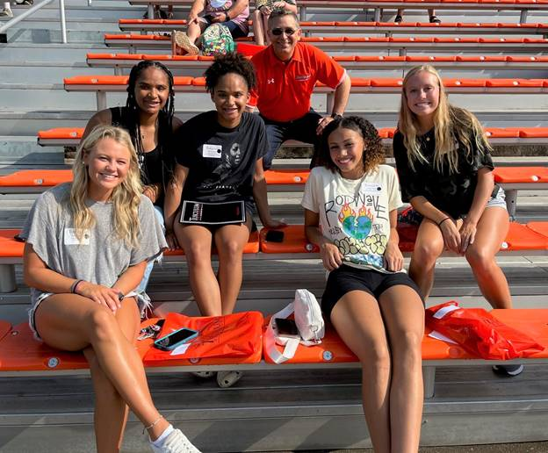

Dr. Hummel greets some of our incoming students for the fall during Pioneer Quest Friday, June 17. This was a fun event that enabled these students to learn more about Tusculum, and they were able to meet and have their photo with Zeke! More event photos are available in [this gallery](https://www3.tusculum.edu/news/tusc-family/2022/pioneer-quest-photos-june-2022/). Photos by the Office of Communications and Marketing.

**Introducing Tusculum’s new campus minister!**

We welcome Dr. Chris Shumate to the Tusculum family as our new campus minister and are grateful he has responded to God’s call to assist students, faculty and staff with their spiritual development.

Dr. Shumate will begin his service Friday, July 1. His office will be in the Scott M. Niswonger Commons, but you can expect to see him engaging with students, faculty and staff at locations throughout the university. He will direct and expand the university’s spiritual development opportunities and continue to grow our faith-based institution’s relationships with local churches.

Dr. Shumate was raised just a few miles from campus and is excited about returning to Greeneville and Greene County. He said everyone he has met at Tusculum has been kind, and he looks forward to joining the Tusculum family and being on campus. Dr. Shumate said he loves the university’s mission statement and Dr. Hummel’s vision for Tusculum.

“I believe that a university is a very strategic place to serve others and influence people for Christ,” Dr. Shumate said. “Young adults are so special. They have such energy and enthusiasm. I thank God, Dr. Hummel and all of the other people who played a part in helping lead me to Tusculum.”

Dr. Shumate earned a bachelor’s degree in sociology, with a minor in Appalachian studies, from East Tennessee State University and a Master of Divinity in Christian apologetics and a Doctor of Ministry in disciple-making, both from Southeastern Baptist Theological Seminary.

“We are grateful Chris has responded to God’s call and chosen to help Tusculum family members on their spiritual journeys,” said Dr. Scott Hummel, Tusculum’s president. “Chris will be a tremendous asset for Tusculum family members at all stages of faith and further demonstrate our caring Christian environment.”

You can learn more about Dr. Shumate in this [news release](https://www3.tusculum.edu/news/tusc-family/2022/dr-chris-shumate-who-has-served-people-of-faith-for-more-than-15-years-named-tusculums-campus-minister/).

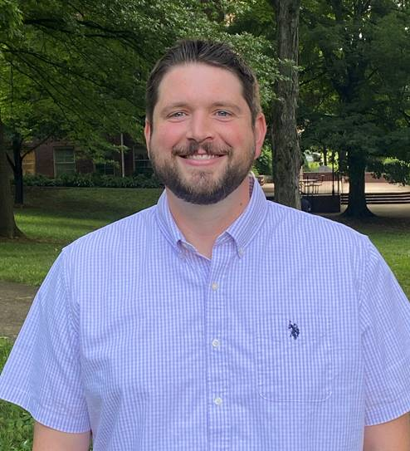

Dr. Chris Shumate

**Appalachian Environmental Studies Summer Series starts this week!**

Our Appalachian Environmental Studies program’s summer lecture series begins Tuesday, June 21, at 6 p.m. in the Meen Center lecture hall and is expected to last until 7:30 p.m. You can also access this week’s event via Zoom at <https://tusculum.zoom.us/j/83145285352>.

The participants and their presentations will be:

·         Dr. Susan Monteleone, associate professor of biology, “Conservation Biology and Sustainable Development”

·         Dr. Conor Keitzer, assistant professor of natural sciences, “Natural History and the Appalachian Region”

·         Vicky Johnson-Bós, assistant professor of English, “Appalachian Literature and the Environment”

·         Dr. Troy Goodale, professor of political science and chair of the Department of Social Sciences, “Environmental Law and Politics”

The second and final session will be at 6 p.m. Tuesday, Aug. 9, at the Greene Technology Center and likewise last about 90 minutes. The same Zoom link will be available. The participants and their talks will be:

·         Dr. Angela Keaton, professor of history, “Appalachian History and the Environment”

·         Dr. Shelby Ward, adjunct professor of political science, “Environmental Political Theory: Understanding Space and Places in Appalachia”

·         Dr. Heather Henson-Ramsey, dean of the College of Science, Technology and Mathematics, “Environmental Health Issues in Appalachia”

·         Dr. Goodale, "The Diversity of Appalachia”

Attendance both nights is free and open to all Tusculum family members and the community. A panel discussion and questions from the audience will conclude each session. You can read more in this [news release](https://www3.tusculum.edu/news/news/2022/tusculums-department-of-social-sciences-sponsoring-lecture-series-that-will-examine-the-environment-from-multiple-angles/).

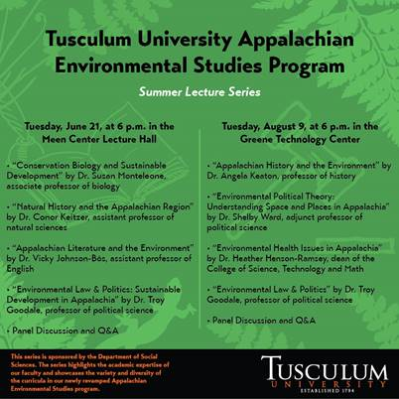

**Exciting final two presentations coming in the History Summer Lecture Series!**

We encourage you to join us for the second and third presentations of the three-session History Summer Lecture Series, “Sketches of East Tennessee History,” at 6 p.m. Wednesday, June 22, and Thursday, June 30, in the Meen Center lecture hall.

The subjects will be:

·         "‘The Rail-splitter and the Tailor’: Efforts to Bind Andrew Johnson's Legacy to Lincoln in the Early-20th Century" by Dr. Jeffrey Perry, assistant professor of history at Tusculum – June 22

·         “Exploring Shaver: ETHC Collection and Beyond” by Rebecca P’Simer, curator of collections at the East Tennessee Historical Society in Knoxville – June 30

We thank Emily Morrell, a doctoral student in history at West Virginia University for her great lecture, “Who Was John Gloucester?: Race, Place and Religion at Greeneville College in 1806,” which led off the series.

The College of Civic and Liberal Arts; the Department of History, Museum Studies, and Religion; and the Doak House Museum are sponsoring the series. You can read more about the series [here](https://www3.tusculum.edu/news/news/2022/lecture-series-at-tusculum-university-in-june-will-discuss-three-important-figures-in-east-tennessee-history/). The lectures are free, but donations are welcome.

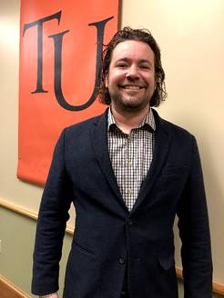

Dr. Jeffrey Perry



Rebecca P’Simer

**Check out the Tusculum garage sale for neat items!**

Tusculum will hold a garage sale this week that will enable faculty, staff and students, as well as community members, to look for that special item.

The sale will take place from 8 a.m.-4 p.m. Thursday and 7 a.m.-noon Friday in front of the Scott M. Niswonger Commons at Tusculum’s warehouse, which is located at 112 Polk St. – behind the Food City – in Greeneville.

Items for sale include Tusculum apparel, accessories, desks, chairs, filing cabinets, household furniture and books. Tusculum will accept all forms of payment.



**Dr. Hummel appears on a local public affairs program**

We had a great opportunity to share the Tusculum story this week when Dr. Hummel appeared on “A Closer Look,” a public affairs program on Holston Valley Broadcasting television stations such as MeTV and radio stations such as WFTM.

Dr. Hummel sat with host Lynda Fontaine for the 12-minute interview, which aired Sunday. He was able to highlight exciting things happening at Tusculum, including our extensive student research and the growing music program.

He also talked about the affordability of a Tusculum education and the university's support of first-generation students. In addition, he discussed Tusculum being a faith-based higher education institution and providing a caring Christian environment.

You can view the interview [here](https://youtu.be/5TctIL9UL7M).

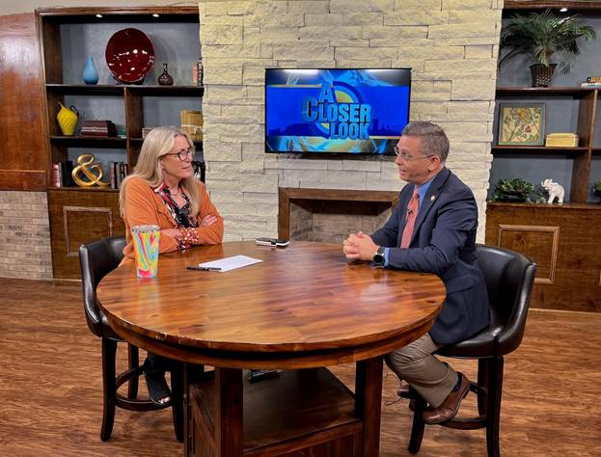

Dr. Hummel, right, speaks with host Lynda Fontaine during the taping of “A Closer Look.” Photo by the Office of Communications and Marketing

**Two students conducting surveys for their research studies, needing participants**

Students Avery Carper and Sarah Calfee, who were selected as Ledford Scholars for the summer, are needing assistance from Tusculum family members with their research projects.

Both are working under the guidance of Dr. Kate Smith, associate professor of psychology, and Dr. Hollie Pellosmaa, assistant professor of psychology. Carper’s project is a collaboration with the Tusculum Psychology Department to study the stigma associated with mental health services. Calfee is partnering with the department to examine the ways that participant's stress might impact their heart health.

The students are seeking participation by Friday, July 8. Carper’s study is open to students, faculty and staff, and Calfee’s is limited to faculty and staff.

Carper’s survey is multipronged and takes about 20 minutes to complete. It is available at<https://utk.co1.qualtrics.com/jfe/form/SV_9StC1HkcJ1bqioe>. Participants are entered into a drawing for a $20 Amazon gift card.

Calfee’s study requires employees to participate in person. To schedule an appointment, please visit<https://calendly.com/tupsycresearch>. Participants will be entered into a drawing for a $50 Amazon gift card.

Further details are attached to this edition of The Pioneer Press.

**Opportunity to support the food drive for summer residential students**

Some of our students have needed to stay in the residence halls this summer, and we can support them.

The Bonner Leader Program is holding a food drive for these students. To support this initiative, you can leave perishable food items in the bin by the Old Gym in the Scott M. Niswonger Commons or at the Center for Civic Advancement, which is located in Room 401 of that building.

You are also welcome to make a monetary donation [here](https://ssl.charityweb.net/tusculum/). Please select the food pantry in the drop-down menu.

**Our summer camps for children of all ages are can’t-miss activities!**

Remember Tusculum will host several affordable summer camps on campus in July. Here is the lineup:

·         Tool School, July 11-15

·         Find Your Food, Find Your Fun, July 25-29

·         Health Professions Day Camp, July 19

·         Theatre Camp at Tusculum, July 25-29

We encourage your families to participate and ask you to alert others as well.

Additional details and registration are available at <https://tusculumuniversitycamps.totalcamps.com/>. For more information, please email Greg Fay, director of continuing education and camps, at [gfay@tusculum.edu](mailto:gfay@tusculum.edu).

**Mark your calendar now for the Tusculum Family Reunion!**

The university will hold its first Tusculum Family Reunion, which will feature food, fun and games, for faculty and staff members Monday, Aug. 15,, from 11 a.m.-2 p.m. in Pioneer Park, our beautiful baseball stadium!

This event will enable employees to meet faculty and staff members who have recently begun working at Tusculum. Family members of employees are welcome to attend if their schedule permits. The event will be casual. Information about food will be forthcoming.

In addition to games such as cornhole, water balloon toss and mummy wrap, we will have a softball game at noon.

We will also have prize drawings. Faculty and staff members will receive their ticket and name tag when they enter the front gate of Pioneer Park.

Rose Peedin, executive assistant to the president, is seeking volunteers to assist with the games. If you can help, please email her at [rpeedin@tusculum.edu](mailto:rpeedin@tusculum.edu).



**Local students benefited from the Band Camp on campus**

Students from Greeneville and Greene County sharpened their musical skills under the tutelage of Tusculum faculty members last week.

Tusculum held Band Camp for these students in Annie Hogan Byrd Fine Arts Center and the Meen Center Thursday through Saturday. The event included several rehearsals, sectionals, lessons on music theory and a talent show. The camp concluded with a concert that featured the songs “Echoes,” “Romanesque,” “The Great Escape,” “Sea Songs” and “Alamo.” The group also performed selections from the movie “Les Miserables.”

Dr. David Gonzalez, director of bands, led the camp and was assisted by adjunct professors and students in the Tusculum band program.

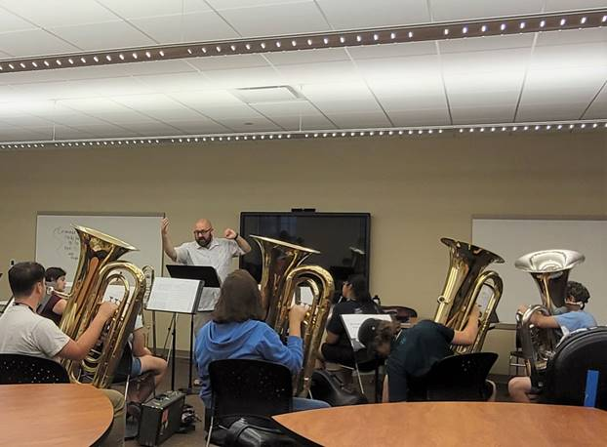

Students receive a lesson during Band Camp in this photo taken by Jyclyn West. Other photos by her and the Office of Communications and Marketing are available [here](https://www3.tusculum.edu/news/tusc-family/2022/band-camp-photos/).

**Basketball camp has a huge turnout!**

Building on an already busy summer on campus, Coach JT Burton brought large numbers of students and their families to Tusculum last week.

We were pleased to host the JT Burton Team Camp Tuesday through Thursday. The camp brought about 100 basketball teams and 1,000 players, ages 12-18, to the campus and the community! Pioneer Arena and the Old Gym were bustling places with games throughout the day.

We were pleased to have these guests on campus!

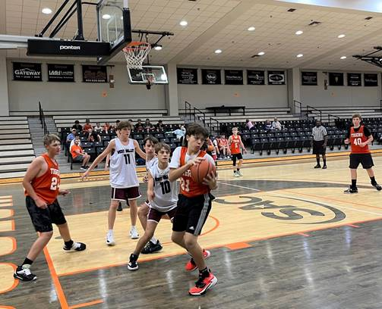

Here are a couple of the teams in action at the camp. Others are available [here](https://www3.tusculum.edu/news/tusc-family/2022/jt-burton-camp-2022/). Photos by the Office of Communications and Marketing

**Congratulations to a former Pioneer who wins golf tournament**

Former Tusculum University All-American Brad Hawkins won the 2022 Tennessee State Open Golf Championship on Thursday, June 9, held in Chattanooga.

The Tusculum sports hall of famer won the title by one shot with a 54-hole score of -12. He was one of 145 golfers in the tournament.

The 2016 Tusculum graduate played two seasons with the Pioneers and was a two-time All-South Atlantic Conference first team selection. During his senior season, he was the South Atlantic Conference Men's Golfer of the Year.

You can read more in this [news release](https://tusculum.prestosports.com/sports/mgolf/2021-22/releases/20220610fkjfym).



Brad Hawkins holds his tournament-winning trophy. Photo from the Office of Athletic Communications

**Alumnus featured, student on the cover in local magazine**

Keddrain Bowen, a 2003 Tusculum graduate, was featured in the June edition of The Business Journal of Tri-Cities Tennessee/Virginia.

The story references his time at Tusculum and his operation of Fanatics 101 sports apparel items stores in Johnson City and Asheville, North Carolina. The article also discusses the book he recently wrote, “The Dream is Free.” He was part of Authors’ Row at the Old Oak Festival in April.

In addition to Bowen, current student Haley Gibson appeared on the front cover and in three other photos in the magazine along with students from other higher education institutions in Northeast Tennessee and Southwest Virginia, where the magazine circulates. Every June, the magazine focuses on higher education.

You can access the magazine [here](https://indd.adobe.com/view/86aa147b-2a59-42ac-862a-1df9f5ab6f94).

**Late summer term starts next Monday; register now for big savings!**

Last chance! Students should take advantage of the large financial benefit by registering for the late summer term, which runs from June 27-Aug. 12.

Students can save $418 per credit hour – 53 percent – for undergraduate courses compared to the fall and spring semesters by taking summer courses! The cost for these courses is just $365 per credit hour.

Federal financial aid is available to students to cover their tuition costs, too!

The link to the portal is <https://portal.tusculum.edu/CMCportal/>. The students’ login is their Tusculum lab account. This is the same username and password utilized for Canvas.

Students should check with the Tusculum financial aid team and their advisor. Students cannot register for the summer terms if they have a business hold or have not met with their advisor.



**Register now for fall courses!**

Students who have not completed registration for fall classes should take care of that task as soon as possible. They can review courses available during the fall semester by visiting the portal.

It is important for students to remember:

·         They must meet with their advisor before they can choose their courses.

·         They must not have a business office hold on their student account because they will not be able to register for courses until they resolve it.



**Sign up for housing for the fall semester!**

Students preparing for the fall semester should take a few moments to sign up for housing.

The application is available at <https://my.tusculum.edu/forms/housing-lottery-form/>.

Here are a few important reminders about housing registration:

·         Students will not be able to participate in the housing lottery if they have not registered for courses to be held in the fall.

·         Students need to complete a housing application on their Anthology accounts.

·         Students who have a business office hold can submit their housing application, but it will not be processed until they register for classes for the fall.



**Updated financial forms now on the website**

Eight updated forms and one handbook have been added to the [finance documents and forms page](https://www3.tusculum.edu/finance/) of the Tusculum website.

They are:

·         Capital budget request form

·         Deposit form

·         Employee request for expense reimbursement form

·         Petty cash request form

·         Request for disposal of university property

·         Request for payment form

·         Vehicle mileage form

·         W-9 form

·         Financial procedures handbook

Please use these items moving forward.

**Reminders**

·         Join us in the living room of the Scott M. Niswonger Commons at 1 p.m. Wednesday, July 20, as we recognize retirees Jane Brown, Deborah Gietema, Jennifer Hollowell, Dr. Lisa Johnson and Teresa Smith. We will have cake, punch and plenty of opportunity for fellowship. All faculty and staff members are invited.

·         Faculty and staff members are eligible to receive free tickets for Greeneville Flyboys home games at Pioneer Park this year. Anyone who is interested should submit a request to [tuwork@tusculum.edu](mailto:tuwork@tusculum.edu)no later than noon on a game day or by noon on Friday for weekend games. Employees are eligible to reserve as many as four tickets while supplies last. If the university has not issued its total allotment of tickets as of the noon deadline, an employee can obtain additional ones.

·         If you are holding an event on campus, we need to be sure Tusculum family members are aware. One way is to submit a [branding request](https://iasite.tusculum.edu/branding-project-request-form/) to the Office of Communications and Marketing, which will post the event to the calendar on the Tusculum website. Another is for employees to work with the person designated in their office or department who has the ability to post items on the Events and Planning Calendar on Outlook. Access to items on that calendar is available to all employees.

**Events and activities**

**All Tusculum family members**

Tuesday, June 21, 6 p.m., Meen Center lecture hall and Zoom (<https://tusculum.zoom.us/j/83145285352>);**Appalachian Environmental Studies summer lecture series**

Wednesday, June 22, 6 p.m., Meen Center lecture hall; **“Sketches of East Tennessee History” lecture "‘The Rail-splitter and the Tailor’: Efforts to Bind Andrew Johnson's Legacy to Lincoln in the Early-20th Century"**

Thursday, June 23; Tuesday, June 28; and Thursday, June 30, 7 p.m., Chalmers Conference Center; **REFIT fitness class**

Thursday, June 30, 6 p.m. Meen Center lecture hall;**“Sketches of East Tennessee History” lecture “Exploring Shaver: ETHC Collection and Beyond”**

**Community**

Saturday, June 25, and Saturday, July 2, 9 a.m., Doak House Museum; **Greeneville Farmers Market**

**Faculty and staff birthdays**

·         Wednesday, June 22 – Matthew Harrison

·         Friday, June 24 – Shayne Cowden

·         Sunday, June 26 – Kristen Davenport

·         Monday, June 27 – Lanna Monday

·         Monday, June 27 – Nicki Ellenburg

·         Tuesday, June 28 – McKinlay Bryant

·         Wednesday, June 29 – Jenna Restivo

·         Thursday, June 30 – Zachary Shephard

·         Sunday, July 3 – Eric Krenz

We thank you for reading The Pioneer Press! To suggest content for a future edition or submit feature photos, please email Jim Wozniak, director of communications and marketing, at [jwozniak@tusculum.edu](mailto:jwozniak@tusculum.edu).

**Go Pioneers!**