

We hope everyone has a terrific Independence Day and reflects on the blessings we have received in the United States.

**In this edition:**

·         President’s Perspective

·         Word of the Week

·         Photo of the Week

·         Tusculum selects theme for 2022-23

·         Using the correct email signature

·         Summer camps fill July

·         Second session of Appalachian Environmental Studies summer lecture series

·         Helping two Tusculum students with their research studies

·         Three Tusculum TRIO students at national event in Washington

·         Supporting the summer food drive for summer residential students

·         Jordan Baker named director of the Honors Program

·         Tusculum Family Reunion in August

·         Reception for our retirees

·         Planning for the fall semester

·         Fall course registration

·         Signing up for housing

·         The Pioneer Press now available online

·         Reminders

·         Events and activities

·         Faculty and staff birthdays

**President’s Perspective**

While I was in Jerusalem last week, I walked to Independence Park, and it reminded me of my first “Independence Day” (Yom Ha’atzmaut) in Israel when I was a graduate student at the Hebrew University.

I had never seen such excitement, pride and gratitude for independence. Having grown up in a military family, I feel great pride in being an American. As you celebrate our Independence Day, I hope you enjoy time off, good food and fireworks.

Even at a time when national pride is at an all-time low, I hope you are grateful for our military, military families and veterans for ensuring our continued freedom. I also hope we can express our gratitude by helping to make our country “a more perfect union” by being “civically engaged.”

One of the reasons I am proud to be at Tusculum is because inspiring civic engagement is central to our mission. One of our goals is helping our students become better citizens.

Go Pioneers!

Dr. Scott Hummel  
President

**Word of the Week**

“Now the Lord is the Spirit, and where the Spirit of the Lord is, there is freedom.” – 2 Corinthians 3:17 (ESV)

**Photo of the Week**

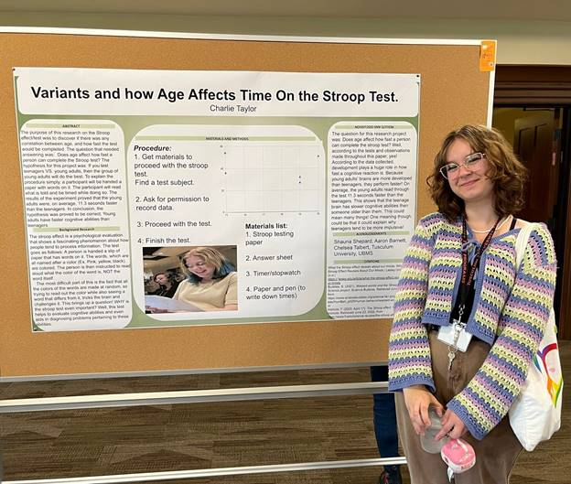

Participants in the Upward Bound and Upward Bound Math and Science summer program completed their five weeks of classes and activities on campus by showcasing their work and knowledge! You can see more photos by the Office of Communications and Marketing in [this gallery](https://www3.tusculum.edu/news/tusc-family/2022/upward-bound-presentation-photos/). Some of these students head to New Orleans Tuesday, July 5, for the annual summer trip.

**Tusculum selects theme for 2022-23**

We are pleased to share our theme for the 2022-23 academic year. It is “Be the Light” from Matthew 5:14-16, which describes our responsibility to be light in the world.

This theme ties nicely into Tusculum’s motto – “[Sit Lux](https://web.tusculum.edu/about/history/sit-lux/)” – which means “let there be light.”

“As a faith-based university, we share the light of knowledge and truth within a caring Christian environment,” Dr. Hummel said. “We prepare students to make a difference and to improve the world around them. We are Pioneers, we are difference makers and we are to be the light.”

We encourage faculty and staff members to modify their email signature to include the new theme.

**Using the correct email signature**

As representatives of Tusculum, we serve as ambassadors for the university and help others understand what defines our higher education institution.

One of the easiest ways for us to accomplish that goal is through our email signature. Tusculum has an email signature convention that is designed to reinforce our branding and provide consistency in our messages to internal and external stakeholders.

Attached to this edition of The Pioneer Press is the updated template, which incorporates the new Tusculum theme. Please review and use for your new signature.

**Summer camps filling the July calendar at Tusculum!**

We remind you that Tusculum will host several affordable summer camps on campus in July. Here is the list:

·         Tool School, July 11-15

·         Health Professions Day Camp, July 19

·         Find Your Food, Find Your Fun, July 25-29

·         Theatre Camp at Tusculum, July 25-29

We encourage your families to participate and ask you to alert others as well.

Additional details and registration are available at <https://tusculumuniversitycamps.totalcamps.com/>. You can also learn more by reading this [news release](https://www3.tusculum.edu/news/news/2022/multiple-summer-camps-at-tusculum-to-provide-active-and-experiential-learning-opportunities-for-children-of-all-ages/). For more information, please email Greg Fay, director of continuing education and camps, at [gfay@tusculum.edu](mailto:gfay@tusculum.edu).

**Second Appalachian Environmental Studies series session coming in August!**

Engage with an outstanding lineup of Tusculum faculty members when the Appalachian Environmental Studies program’s summer lecture series returns Tuesday, Aug. 9, at 6 p.m. at the Greene Technology Center for its final session.

If you cannot attend in person, you can access the event via Zoom at<https://tusculum.zoom.us/j/83145285352>.

The participants and their presentations will be:

·         Dr. Angela Keaton, professor of history, “Appalachian History and the Environment”

·         Dr. Shelby Ward, adjunct professor of political science, “Environmental Political Theory: Understanding Space and Places in Appalachia”

·         Dr. Heather Henson-Ramsey, dean of the College of Science, Technology and Mathematics, “Environmental Health Issues in Appalachia”

·         Dr. Troy Goodale, professor of political science and chair of the Department of Social Sciences, "The Diversity of Appalachia”

Attendance is free and open to all Tusculum family members and the community. A panel discussion and questions from the audience will follow the talks.

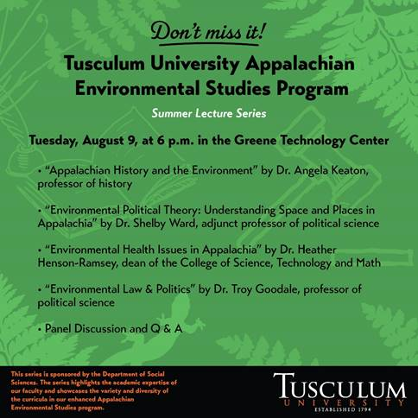

**Deadline this week to help two students with research studies**

If you want to assist students Avery Carper and Sarah Calfee with their summer research projects, the deadline is Friday, July 8. Carper’s study is open to students, faculty and staff, and Calfee’s is limited to faculty and staff.

The students are working under the guidance of Dr. Kate Smith, associate professor of psychology, and Dr. Hollie Pellosmaa, assistant professor of psychology. Carper’s project is a collaboration with the Tusculum Psychology Department to study the stigma associated with mental health services. Calfee is partnering with the department to examine the ways that participants’ stress might impact their heart health. They are conducting their research this summer as Ledford Scholars.

Carper’s survey is multipronged and takes about 20 minutes to complete. It is available at<https://utk.co1.qualtrics.com/jfe/form/SV_9StC1HkcJ1bqioe>. Participants are entered into a drawing for a $20 Amazon gift card.

Calfee’s study requires employees to participate in person. To schedule an appointment, please visit<https://calendly.com/tupsycresearch>. Participants are entered into a drawing for a $50 Amazon gift card. Further details are attached.



Avery Carper

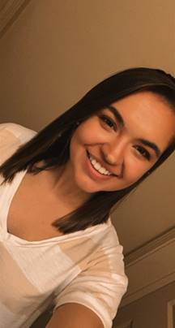

Sarah Calfee

**Tusculum TRIO students participate in national event!**

Three students in Tusculum’s TRIO programs recently participated in the Council for Opportunity in Education’s National Student Leadership Congress in Washington. They are:

·         Joseph Cole, a Talent Search participant from South Greene High School

·         William Stokes, an Upward Bound Math and Science participant from South Greene High School

·         Amelia Yarber, an Upward Bound participant from Unicoi County High School

Each summer, COE hosts more than 150 TRIO high school student delegates from Upward Bound and Talent Search programs across the United States and territories to participate in a rigorous six-day leadership experience. During National Student Leadership Congress, student delegates reside at Georgetown University, where they conduct research to present a bill to a mock Congress.

Group members engage in conflict resolution workshops and diversity training and spend much of the program researching a critical and controversial current policy issue, drafting legislation and arguing their position. At the conclusion of the event, participants meet their senators and representatives on Capitol Hill.

Tusculum’s TRIO programs have a long history of students being selected for participation in this national event.

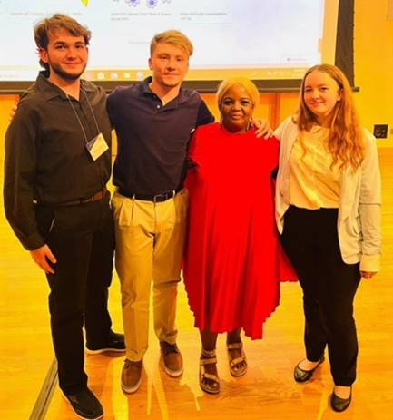

William Stokes, Joseph Cole, and Amelia Yarber with Dr. Tracy Lyons, National Student Leadership Congress co-director. Photo from Dr. David Smith

**Be sure to support the food drive for summer residential students**

Some of our students have needed to stay in the residence halls this summer, and we can help them.

The Bonner Leader Program is holding a food drive for these students. To support this initiative, you can leave perishable food items in the bin by the Old Gym in the Scott M. Niswonger Commons or at the Center for Civic Advancement, which is located in Room 401 of that building.

You are also welcome to make a monetary donation [here](https://ssl.charityweb.net/tusculum/). Please select the food pantry in the drop-down menu.

**Jordan Baker named director of the Honors Program**

Jordan Baker, assistant professor of biology, has been named director of Tusculum’s Honors Program.

A Tusculum faculty member since 2018, Baker is an integral member of the university, participating in multiple programs in addition to his teaching duties. His service to the university includes serving as chair of the Undergraduate Curriculum Committee and as a Faculty Council member.

Baker is the faculty representative of the University Athletic Advisory Committee and the First-gen Forward Task Force. He is faculty co-advisor of the Science Club and faculty advisor of the Breaking Bread ministry.

He holds a bachelor’s degree in biology from Lenoir-Rhyne University and a master’s degree in biology from East Tennessee State University.

Acceptance into the Honors program is a recognition of a student’s academic achievement and potential for further success. The Honors Program gives members a competitive advantage as they begin their graduate studies or career. Among the benefits of the Tusculum program are specialized curriculum, opportunities to be published as an undergraduate and participation in cultural events. The university also offers an honors minor.

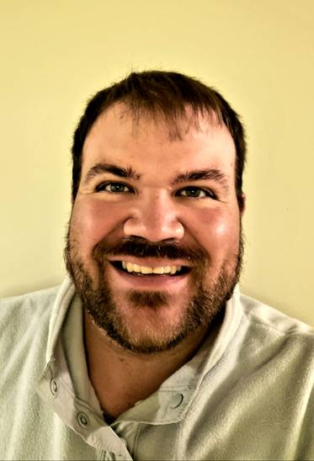

Jordan Baker

**Be ready for fun at the Tusculum Family Reunion!**

Faculty and staff members are invited Monday, Aug. 15, to enjoy lots of food, fun and games at Tusculum Family Reunion.

The can’t-miss event will be held 11 a.m.-2 p.m. in Pioneer Park! Dress is casual.

In addition to games such as cornhole, water balloon toss and mummy wrap, we will have a softball game at noon. We will also have prize drawings. Faculty and staff members will receive their ticket and name tag when they enter the front gate of Pioneer Park.

Family members of employees are welcome to attend if their schedule permits!

Rose Peedin, executive assistant to the president, is seeking volunteers to assist with the games. If you can help, please email her at [rpeedin@tusculum.edu](mailto:rpeedin@tusculum.edu).

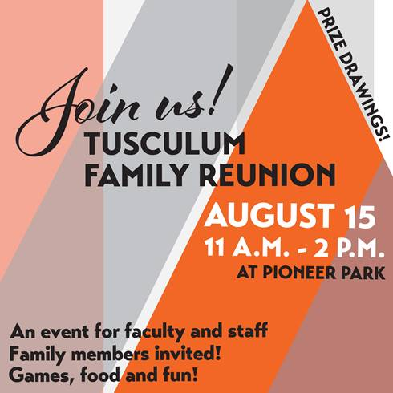

**Celebrating our retirees!**

We encourage you to join us in the living room of the Scott M. Niswonger Commons at 1 p.m. Wednesday, July 20, to honor recent retirees!

Tusculum will recognize the following employees for their exemplary service to the university:

·         Jane Brown from the College of Nursing

·         Deborah Gietema from the College of Science, Technology and Mathematics

·         Jennifer Hollowell from Arts Outreach

·         Dr. Lisa Johnson-Neas from the Office of Student Affairs

·         Teresa Smith from the College of Civic and Liberal Arts

We will have cake, punch and abundant opportunities for fellowship. All faculty and staff members are invited!

**Key dates to prepare for the fall semester**

As we move into July, faculty and staff members are making preparations for the start of the fall semester.

A planning team, led by Dr. Hummel, has met regularly since the conclusion of the spring semester to plan Pioneer WOW. The bulk of the activities geared toward new students will be held Thursday, Aug. 18-Saturday, Aug. 20. A variety of other activities will also take place Sunday, Aug. 21-Saturday, Aug. 27.

The Office of Academic Affairs has scheduled the Pioneer Workshop for faculty and staff to be held from 9 a.m.-noon Tuesday, Aug. 16. The location for the workshop is to be determined. This is an excellent opportunity to receive important updates so we can hit the ground running when classes start Monday, Aug. 22.

Then, once the fall semester has begun, we will hold the Opening Convocation Tuesday, Aug. 23, at 10 a.m. in Annie Hogan Byrd Fine Arts Center. This formal event is a great way to celebrate the start of an excellent academic year on campus.

The excitement is building!

**Fall course registration available now!**

Students who have not registered for fall classes should not wait! They can review courses available during the fall semester by visiting the portal.

It is essential that students remember:

·         They must meet with their advisor before they can choose their courses.

·         They must not have a business office hold on their student account because they will not be able to register for courses until they resolve it.



**Line up housing for the fall semester!**

Students who want to live in a residence hall for the fall semester need to sign up for housing.

The application is available at <https://my.tusculum.edu/forms/housing-lottery-form/>.

Here are a few important tips about housing registration:

·         Students will not be able to participate in the housing lottery if they have not registered for courses to be held in the fall.

·         Students need to complete a housing application on their Anthology accounts.

·         Students who have a business office hold can submit their housing application, but it will not be processed until they register for classes for the fall.

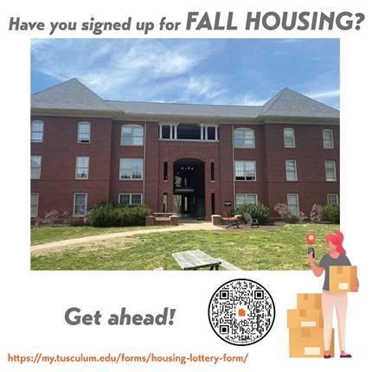

**The Pioneer Press is also available online**

If you need to review something in The Pioneer Press and cannot find it in your email, you have another avenue.

The most current edition of The Pioneer Press is now available through the Pioneer Portal. Simply go to the home page of the [Pioneer Portal](https://site.tusculum.edu/tusculum-pioneers/) and see The Pioneer Press icon. Click on that to read The Pioneer Press.

We are also working to create an archive of prior editions.

**Reminders**

·         Faculty and staff members are eligible to receive free tickets for Greeneville Flyboys home games at Pioneer Park this year. Anyone who is interested should submit a request to [tuwork@tusculum.edu](mailto:tuwork@tusculum.edu)no later than noon on a game day or by noon on Friday for weekend games. Employees are eligible to reserve as many as four tickets while supplies last. If the university has not issued its total allotment of tickets as of the noon deadline, an employee can obtain additional ones.

·         Eight updated forms and one handbook have been added to the [finance documents and forms page](https://www3.tusculum.edu/finance/) of the Tusculum website. Please use these items moving forward.

·         If you are holding an event on campus, we need to be sure Tusculum family members are aware. One way is to submit a [branding request](https://iasite.tusculum.edu/branding-project-request-form/) to the Office of Communications and Marketing, which will post the event to the calendar on the Tusculum website. Another is for employees to work with the person designated in their office or department who has the ability to post items on the Events and Planning Calendar on Outlook. Access to items on that calendar is available to all employees.

**Events and activities**

**All Tusculum family members**

Tuesday, July 5; Thursday, July 7, Tuesday, July 12; and Thursday, July 14, 7 p.m., Chalmers Conference Center; **REFIT fitness class**

Wednesday, July 6, 11 a.m., in front of the Scott M. Niswonger Commons; **Project Waffle food truck**

**Faculty and staff**

Monday, July 11-Friday, July 15, 9 a.m., Doak House Museum: **Tool School**

Thursday, July 14, 9 a.m., Zoom;**Operations Success Committee**

Friday, July 15, 9 a.m., Greeneville campus; **Pioneer Quest**

**Community**

Saturday, Saturday, July 9, and Saturday, July 16, 9 a.m., Doak House Museum; **Greeneville Farmers Market**

**Faculty and staff birthdays**

·         Wednesday, July 6 – Jennifer Fincher

·         Friday, July 8 – Josh Ealy

·         Friday, July 8 – Amber Weber

·         Thursday, July 14 – David Crum

·         Friday, July 15 – Michael Davis

·         Saturday, July 16 – Shelby Fillers-Charron

·         Saturday, July 16 – Dr. Derrick Proffitt

·         Sunday, July 17 – Dr. Harold Branstrator

We thank you for reading The Pioneer Press! To suggest content for a future edition or submit feature photos, please email Jim Wozniak, director of communications and marketing, at [jwozniak@tusculum.edu](mailto:jwozniak@tusculum.edu).

**Go Pioneers!**