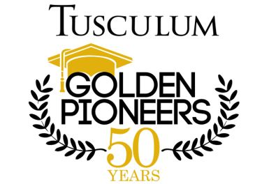

Friday, May 5th, 2023
3:00 p.m. Registration at Welcome Center
4:00 p.m. Tour of Campus Provided by Admission Staff
5:00 p.m. Review of Class Records – Dr. Peter Noll
6:00 p.m. Welcome and Invocation – Dr. Scott Hummel, President
Celebration Dinner
7:00 p.m. Medallion Ceremony – Dr. Hummel and Belle Kemp
7:20 p.m. Commencement Information – Belle Kemp
7:30 p.m. Benediction – Dr. Hummel

Saturday, May 6th, 2023
9:00 a.m. Robing in Brotherton Board Room (Meen Center)
Complimentary Breakfast
9:30 a.m. Golden Pioneers Line Up and Walk to Procession Area
9:40 a.m. Escort Golden Pioneer Guests to Arena
10:00 a.m. Commencement (Pioneer Park)
11:15 a.m. Return to Meen Board Room for Lunch

