SECTION 8: Student Achievement

**SACSCOC STANDARD 8.1. The institution identifies, evaluates, and publishes goals and outcomes for student achievement appropriate to the institution’s mission, the nature of the students it serves, and the kinds of programs offered. The institution uses multiple measures to document student success.**

*(Student achievement)* **[Core Requirement]**

Note: The asterisk (*) below indicates the specific metric required by SACSCOC for measuring graduation rate and analyzing that measure of student success and a discussion of the changes the University has implemented to improve student achievement for that measure for all students, as well as those groups of students specifically served by Tusculum.

# TUSCULUM UNIVERSITY MISSION STATEMENT:

Building on a rich Presbyterian heritage and a pioneering spirit, Tusculum University provides an active and experiential education within a caring Christian environment to inspire civic engagement, enrich personal lives, and equip career-ready professionals.

(Approved by the Tusculum University Board of Trustees on May 30, 2020)

The University last reviewed its mission during the 2019-20 academic year. After undertaking a thorough process that involved benchmarking against similar colleges and universities and conducting feedback sessions, surveys, and focus groups with over 400 constituents, the administration presented a revised mission statement to the Board of Trustees at the 698th Meeting of the Board of Trustees on May 30, 2020. The revised statement was approved unanimously.

The mission statement is specific to Tusculum University and addresses its objective of teaching and learning via an active and experiential education. It is distinctive and reflects the University’s commitment to the provision of an education within a caring Christian environment. Lastly, the statement articulates the vision for Tusculum to inspire civic engagement, enrich personal lives, and equip career-ready professionals. It is both descriptive of what the University is and also aspirational for what it strives to be.

# STUDENT ACHIEVEMENT GOALS AND OUTCOMES:

1. STUDENT PERSISTENCE TO GRADUATION*

**MEASURE A-1:**

ONE-YEAR RETENTION RATE: Percentage of first-time, full-time students returning for second year.

TARGET: 60%

Table 1 – Full-time, First-time One-Year Retention Rates

|  |  |  |  |  |  |  |  |  |  |
| --- | --- | --- | --- | --- | --- | --- | --- | --- | --- |
|  | Fall 2013 | Fall 2014 | Fall 2015 | Fall 2016 | Fall 2017 | Fall 2018 | Fall 2019 | Fall 2020 | Fall 2021 |
| % Returning for 2nd Fall Semester | 62% | 59% | 68% | 65% | 54% | 62% | 67% | 61% | 55% |

**MEASURE A-2:**

SIX-YEAR GRADUATION RATE: Percentage of first-time, full-time students graduating within six years.

TARGET: 40%

Table 2 – Full-time, First-time Six-Year Graduation Rates

|  |  |  |  |  |  |  |  |  |  |  |
| --- | --- | --- | --- | --- | --- | --- | --- | --- | --- | --- |
|  | Fall 2007 | Fall 2008 | Fall 2009 | Fall 2010 | Fall 2011 | Fall 2012 | Fall 2013 | Fall 2014 | Fall 2015 | Fall 2016 |
| **% Graduating within Six Years** | 34% | 36% | 36% | 41% | 33% | 31% | 41% | 36% | 41% | 34% |

The University ***exceeded its target*** for the Fall 2015 full-time, first-time cohort. Our average for the last three years was 37%.

**Measure A-3:**

FIRST-TIME, FULL-TIME ONE-YEAR RETENTION AND SIX-YEAR GRADUATION RATES:

Rolling three-year average of one-year retention rate and six-year graduation rate.

TARGET: At or above median value of SACSCOC Comparison Group

Table 3 – Full-time, First-time One-Year Retention & Six-Year Graduation Rates

|  |  |  |  |
| --- | --- | --- | --- |
|  |  | One-Year Retention  (3-Yr Average) | Six-Year Grad Rate  (3-Yr Average) |
| Tusculum University | **TN** | **61%** | **37%** |
| Peer Median |  | **64%** | **35%** |
| Bluefield College | VA | 58% | 35% |
| Campbellsville University | KY | 64% | 36% |
| Ferrum College | VA | 56% | 30% |
| Greensboro College | NC | 65% | 32% |
| Kentucky Wesleyan College | KY | 62% | 42% |
| Lees McRae | NC | 65% | 43% |
| Limestone College | SC | 65% | 32% |
| Lindsey Wilson College | KY | 61% | 40% |
| Mars Hill University | NC | 68% | 33% |
| North Carolina Wesleyan College | NC | 66% | 37% |
| Union College | KY | 64% | 33% |

Source: IPEDS

The University ***exceeded its target*** for six-year graduation rate measures.

**Measure A-4:**

SIX-YEAR GRADUATION RATE: Disaggregated rolling three-year average of six-year graduation rates for distinct student populations served by Tusculum.

TARGET: At or above median value of SACSCOC Comparison Group

|  |  |  |
| --- | --- | --- |
|  | Tusculum | Peer |
| Overall Graduation Rate | 41% | 36% |
| Graduation Rate - Male | 34% | 29% |
| Graduation Rate - Female | 49% | 46% |
| Graduation Rate - Black | 22% | 20% |
| Graduation Rate - Hispanic | 33% | 33% |
| Graduation Rate - White | 48% | 41% |
| Graduation Rate - Pell | 38% | 28% |
| Graduation Rate - Loan/No Pell | 35% | 41% |
| Graduation Rate – No Fed Aid | 55% | 49% |

The extent to which the University ***met its target varied by student group***; Tusculum’s graduation rates are consistently positive compared to the selected peer institutions.

***B. civic engagement & responsibility***

Motivation to make a difference in the civic life of our communities for Tusculum students is measured by voting and registration rates from the National Study of Learning, Voting, and Engagement (NSLVE). The NSLVE is a signature initiative of the Institute for Democracy and Higher Education (IDHE) at Tufts University's Jonathan M. Tisch College of Civic Life. IDHE is an applied research center focused on college and university student political learning and participation in democracy. The voter registration and voting rates in this report reflect the percentage of our institution's students who were eligible to vote and who voted in federal elections. Results are based on enrollment records submitted to the National Student Clearinghouse and publicly available voting files collected by Catalist. Tusculum University has participated in the NSLVE since 2014.

**MEASURE B-1:**

VOTING RATES: the percentage of an institution's students who were eligible to vote and who voted in federal elections.

TARGET: (a) a 3% increase in Tusculum’s voting rate from one period to another and (b) a voting rate that is at or above the voting rate for all institutions.

Table 4 – Voting Rates

|  |  |  |  |
| --- | --- | --- | --- |
| **Presidential Election Years** | **2016** | **2020** | **+/-** |
| Tusculum | 41% | 56% | +15% |
| All Institutions | 51% | 66% | +15% |
| *Difference from All Institutions* | *-10%* | *-10%* | *N/A* |
| **Mid-term Election Years** | **2014** | **2018** | **+/-** |
| Tusculum | 18% | 30% | +12% |
| All Institutions | 20% | 39% | +19% |
| *Difference from All Institutions* | *-2%* | *-9%* | *-7%* |

The University’s Voting Rate increased dramatically, but so did the national rate. The University remains committed in word and deed to encouraging civic engagement and participation.

**MEASURE B-2:**

VOTER REGISTRATION RATES: the percentage of an institution's students who were registered to vote.

TARGET: a 3% increase in Tusculum’s voter registration rate from one period to another.

Table 5 – Voter Registration Rates

|  |  |  |  |
| --- | --- | --- | --- |
| **Presidential Election Years** | **2016** | **2020** | **+/-** |
| Tusculum | 66% | 82% | **+16%** |
| **Mid-term Election Years** | **2014** | **2018** | **+/-** |
| Tusculum | 63% | 73% | +10% |

The target for this goal ***was met***. We expect 2022 rates to be released in late 2023. The next general election data will be released in late 2025.

***C. licensure and professional exams***

**MEASURE C-1:**

NCLEX-RN EXAM: The NCLEX exam, also known as the National Council Licensure Examination, is a standardized test that every state regulatory board uses to determine if a candidate is ready to become licensed as a nurse. It is administered by the National Council of State Boards of Nursing,

TARGET: The graduates of the Tusculum BSN program will attain the standard in the state of Tennessee, which is an 85% pass rate on the NCLEX-RN exam.

Figure 2

Table 6 – NCLEX-RN Exam

|  |  |  |  |  |  |  |
| --- | --- | --- | --- | --- | --- | --- |
|  | 2017 | 2018 | 2019 | 2020 | 2021 | 2022 |
| Graduates | 15 | 26 | 18 | 23 | 15 | 19 |
| Passed NCLEX-RN Exam | 10 | 22 | 14 | 18 | 12 | 15 |
| % Passed | 67% | 85% | 78% | 78% | 80% | 79% |

*Data Retrieved from the Tennessee Board of Nursing report

**MEASURE C-3:**

TENNESSEE STATE BOARD OF EDUCATION CANDIDATE ASSESSMENTS: The Tennessee State Board of Education publishes an annual Teacher Preparation Report Card for each educator preparation program; the data reported here are based on the most current report card. Requirements for licensure have changed dramatically in the state. Exact exams vary according to the student’s intended field of instruction. Our figures, below, represent the most widely utilized assessment

Figure 3

Praxis Assessment                                     2020                       2021                       2022                       State 3 yr

Elementary Ed Social Studies                     52%                        47%                        43%                        58%

Teaching Reading                                         60%                        49%                        51%                        63%

Elem Ed Science                                            63%                        56%                        62%                        62%

Elem Ed Math                                                73%                        53%                        63%                        65%

Employing School Districts

Knox County Schools, Hamblen County Board of Education, Greene County Schools, Kingsport City Schools, Roane County Schools

**MEASURE C-4:**

PEREGRINE BUSINESS ADMINISTRATION OUTBOUND EXAM: Peregrine Academic Services, the higher education division of Peregrine Global Services, provides nationally normed, summative assessment services used by institutions of higher education for internal and external programmatic evaluation. The assessment service is designed to address institutional and programmatic accreditation and certification requirements related to learning outcomes assessment, quality assurance, and external academic benchmarking. The Outbound Exam is administered to the students at the end of the academic program.

TARGET: To score above the average for students from schools within the ACBSP Region 3 (Southeastern Region)

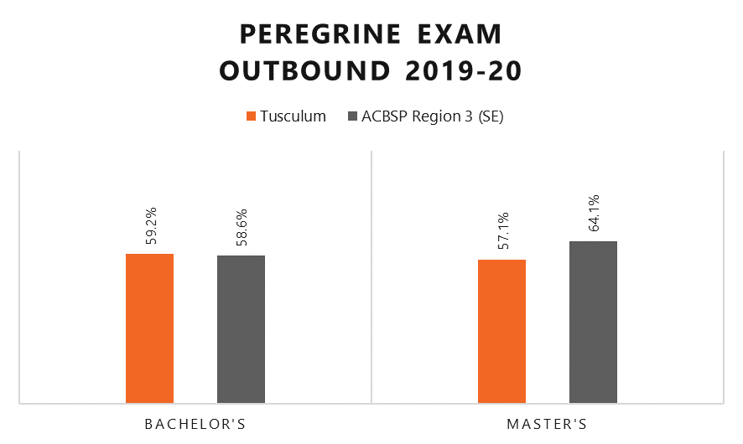

Figure 4

The target for this goal ***was met*** for undergraduate students and not met for graduate students for test takers during the 2019-20 academic year.

***D. Post-Graduation student Success***

Tusculum University administered an exit interview in Spring, 2023.

**MEASURE D-1:**

POST-GRADUATION OUTCOMES BY DEGREE LEVEL: The percentage of completers employed or enrolled in further education such as graduate school.

*\*Knowledge rate = 42%*

Figure 5

**MEASURE D-2:**

POST-GRADUATION CAREER OUTCOME RATE BY DEGREE LEVEL: The career outcome rate is the percentage of completers either employed or enrolled in further education.

98 percent of Tusculum Graduates reported being employed or in advanced education. By comparison, the NACE average for career outcomes is 84 percent. 